Financial Sustainability: Earned, not Given[1]

**An Education Innovation and Research (EIR) Program Dissemination Project White Paper**

Introduction

Education reforms in the United States over the past few years have aimed at addressing persistent achievement gaps by income, ethnicity, special education status, gender, and other critical considerations. Schools and their partners have focused on innovative projects and practices to improve student outcomes; in fact, some have applied for and received funding from the Federal Government to support innovative practices and programs, coupled with rigorous evaluation, to address persistent achievement challenges for students.

**What are i3 and EIR**?

The [Investing in Innovation Fund (i3)](https://innovation.ed.gov/what-we-do/innovation/investing-in-innovation-i3/), established under section 14007 of the American Recovery and Reinvestment Act of 2009, is a Federal discretionary grant program at the U.S. Department of Education within the Office of Innovation and Improvement. i3 grants help schools and local education agencies work in partnership with the private sector and philanthropic community to develop and expand innovative practices that improve student achievement or student growth, close achievement gaps, decrease dropout rates, increase high school graduation rates, or increase college enrollment and completion rates for high-need students.

The [Education Innovation and Research (EIR)](https://innovation.ed.gov/what-we-do/innovation/education-innovation-and-research-eir/) Program, established under section 4611 of the Elementary and Secondary Education Act, as amended by the Every Student Succeeds Act, provides funding to create, develop, implement, replicate, or take to scale entrepreneurial, evidence-based, field-initiated innovations to improve student achievement and attainment for high-need students and rigorously evaluate such innovations. The EIR program is designed to generate and validate solutions to persistent educational challenges and to support the expansion of effective solutions to serve substantially larger numbers of students.

Visit [www.i3community.ed.gov](http://www.i3community.ed.gov) to learn more.

This white paper focuses on organizations that received Investing in Innovation (i3)/Education Innovation and Research (EIR) grants and are implementing innovative, promising, or proven practices. Many of these grantees are focused on balancing their effort to serve more students (getting to scale) with the realities of building a business and funding model that will sustain impacts and growth over the test of time (lasting impacts at scale).

These organizations all need a plan for financial sustainability.

So, what do we mean by “a plan for financial sustainability?” Although it might seem otherwise, a plan for financial sustainability is not just about getting money[2].

We will explore some of the research and lessons learned about financial sustainability by drawing from the government, social, and business sectors. Our research scan and review of case studies from two i3/EIR organizations pursuing this work revealed a truth about financial sustainability that is well articulated by the CEO of the Children’s Literacy Initiative, a 2016 Scale-Up i3 grantee and 2018 EIR Early-Phase grantee: financial sustainability is “earned, not given.”[3]

# Background and Lessons

Organizations aim to sustain impact over time. However, a high percentage of organizations are not able to successfully sustain impact at scale. While there are a host of reasons, the lack of an effective, well-executed financial sustainability plan is one key obstacle.

### What is scaling up?

Cynthia E. Coburn, an education researcher and professor at the School of Education and Social Policy at Northwestern University, identified four dimensions of scaling up: depth, sustainability, spread, and a shift in reform ownership. She suggests that scaling up comprises not just increased users (spread), but also long-term changes in practice and belief (depth), continuation of intervention effects after initial implementation (sustainability), and strong ownership of the reform by districts and schools.[4] i3/EIR grantee strategies to scale up interventions must consider all of these dimensions.

In January 2017, we released a paper titled *Scaling Up Evidence-Based Practices: Strategies from Investing in Innovation[5]*. It captured lessons from nine grantees in scaling up practices to serve more than 1.5 million students through the Federal i3 grant investment alone. The nine i3 grant award recipients shared their experiences scaling up interventions and advice to others trying to grow proven education practices.

The grantees’ experiences suggest the following strategies for scaling up evidence-based practices: (1) use multiple methods to establish buy-in; (2) build a regional and national infrastructure; (3) adapt practice based on evidence; and (4) plan for sustainability from Day 1.

### What is financial sustainability?

Financial sustainability refers to the ability to maintain financial capacity over time.[6] The concept of financial sustainability is embedded in the scaling up definition from Coburn, as sustaining impact at scale after the initial implementation of an intervention would be challenging without a plan for financial sustainability.

To explore financial sustainability approaches and practices with i3/EIR grantees, we leveraged the following frameworks and tools, which we subsequently discuss in brief detail:

1. The *Engine of Impact* framework and “Right To Scale Matrix”[7]
2. The Business Model Canvas and Business Model Design Questions[8]

The *Engine of Impact* framework comprises effective principles and diagnostic tools that organizations can apply and employ to evaluate overall organizational performance and sustainability. This framework can help i3/EIR grantees achieve financial sustainability by evaluating whether funding is an obstacle that may be hindering their organization’s capacity to sustain impact at scale.

The *Engine of Impact* includes seven “essential elements,” described below. These seven principles can help organizations assess their performance, sustain their work, and attract and leverage funding. These essential principles were developed by William F. Meehan III and Kim Starkey Jonker at Stanford University based on a survey of more than 3,000 people who work for nonprofit institutions.

In short, the authors define the following elements as core to nonprofit organizations sustaining impact at scale:

1. Mission: pursuit of a “clear and focused mission.”
2. Strategy: “develop and follow a rigorous, comprehensive strategy.”
3. Impact Evaluation: conduct regular evaluation (including randomized controlled trials or RCTs) to assess results.
4. Insight and Courage: reckon with challenges, see opportunities.
5. Organization and Talent: right people in the right seat, with the right structure.
6. Funding: “adequate funding to meet both program and operational needs.”
7. Board Governance: an effective board.

Beyond this framework, the authors created “[The Right to Scale Matrix](https://ssir.org/articles/entry/earning_the_right_to_scale?),” a diagnostic tool for organizational leaders to assess their organizational performance and readiness to scale up practices. The 2x2 exercise asks organizational leaders to map the strength (on a continuum from weak to strong) of two aspects of their organization: (1) “Finding Your Fuel,” the operational parts of their organization, and (2) “Building and Tuning Your Engine of Impact,” the goals, strategies, evidence, and courage of an organization or program.

The authors describe five regions of the matrix based on the survey of 3,000 nonprofit workers (shown in Figure 1). In brief terms, the areas are:

* Scale Jail (37% of respondents): Need movement on all fronts.
* The Waterfall (15% of respondents): Lots of fuel, need more engine.
* Small is Beautiful (10% of respondents): Keep doing, consider scaling if it makes sense.
* Field of Dreams (17% of respondents): Have results, need fuel.
* The Promised Land (11% of respondents): Focus on innovation and sustainability.

**Figure 1**. Right to Scale Matrix Mapping ANet and Higher Achievement

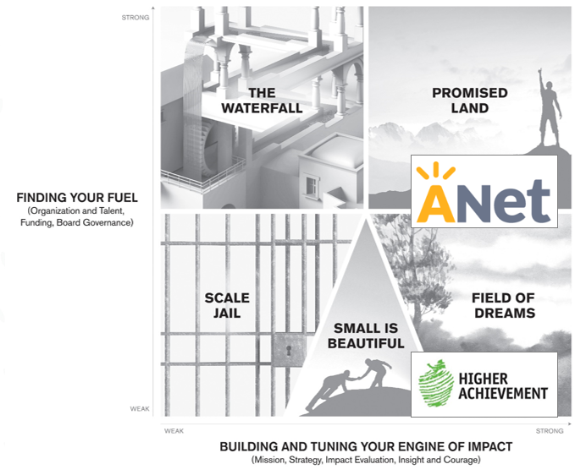

The second set of tools used by grantees to reflect on their sustainability practices was the Business Model Canvas, an approach to developing new or existing business models using a visual chart to describe a firm's or product's value proposition, infrastructure, customers, and finances. It supports alignment of their activities by illustrating potential trade-offs. .[9] In exploring the models of grantees, we asked each to map out their model and aspects of sustainability using the canvas. Additionally, grantees reflected on design questions of their business model using the Business Model Design Questions.

### Grantee Examples

We partnered with two grantees to explore their successes, challenges, and lessons learned around financial sustainability. Each organization placed themselves on the “Right to Scale” matrix — both with clear missions, strategies, impact evaluations, and courage, and at different levels/stages of finding their fuel. Please note that these reflections were based on snapshots in time and may not represent the current statuses of the organizations.

In the following pages, we outline the rationale for each organization’s placement on the “Right to Scale” matrix and dive deeper into each organization’s structures and approaches to financial sustainability.

### Grantee Case Study: Achievement Network (ANet)

For Achievement Net (ANet), financial sustainability “is both art and science — make sure you carefully examine your art.” That is, the organization deems it important to ensure that the science of its business models works, while also playing close attention to the art of achieving great results as operations are scaled to ensure continued returns.

ANet was established in 2005 alongside a group of Boston-based public schools focused on educational equity and excellence for every student. ANet helps school and district leaders catalyze great teaching that is grounded in standards, data, and the practices of great educators. ANet works with over 900 schools serving 300,000 students in 15 states, the equivalent of the 5th largest district in the United States.

The ANet experience begins with the coach, who works with the school’s leadership team to implement a high-quality teaching and learning cycle. ANet helps put this process in place, and after about 3 years the school implements the process on its own. ANet also offers high-quality, standards-aligned materials — assessments, instructional resources, and professional learning tools to maximize the coaching support. ANet does not unbundle the coaching and materials; rather, they are a package deal, as they have found that a powerful impact on student learning occurs when they are coupled together. Some schools continue to use the ANet materials after the 3 years of coaching ends, which provides recurring revenue to support ANet’s continued materials development.

ANet is unique, operating as a small nonprofit within a for-profit/large organization industry of assessment design and implementation support. With close consideration to what makes the ANet model unique, we asked the organization to reflect on a few elements of its financial model using a for-profit-focused tool, shown in Figure 2[10].

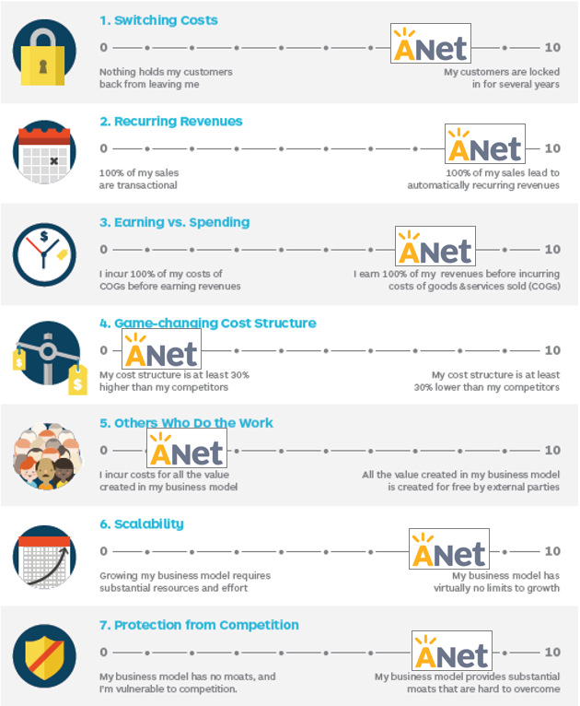Of note, ANet called out the following aspects of its offerings:

**Figure 2.** ANet 7 Questions to Assess Business Model Design

* ANet seeks to work with its partners for at least a 3-year period.
* ANet partners tend to continue use of assessments and materials beyond the initial 3 years if they have built strong practice related to the use of those materials.
* ANet generally earns revenue ahead of expenditures (providing better cash flow).
* ANet’s cost structure is higher than competitors, but its results are evidence-based, and its services are comprehensive (most organizations provide coaching or assessment; ANet provides both).
* ANet has relatively high fixed costs, but once the up-front costs for assessment creation are done, the incremental cost to add additional partners is small (e.g., better to serve more), whereas the coaching model and costs scale at almost a 1:1 basis (with one coach working with about 12 schools).
* ANet is poised to scale, with hiring high-quality coaches and funder match (about 30% of partnership cost underwritten by foundations) as the two main constraints on the pace of growth.
* Given the work on the coaching model, their assessments and materials, evaluation results, and the reputation ANet has achieved, the organization is well insulated from competition.

Beyond the key items discussed above, there are a few critical elements ANet cites that have been foundational to its results and continued growth:

* ANet is crystal clear about its value proposition and its position in the marketplace.
* ANet understands what it offers and what it will not offer (not unbundling assessments from coaching), and it works with partners to get underneath customers’ requests to understand the organization’s goals.
* ANet is very clear that it has two businesses models under one roof that are bundled for the organization’s partners (coaching and materials/assessments).

There are a few additional lessons learned from ANet around financial sustainability:

* Procurement is a real constraint; organizations should take it seriously and plan around it (e.g., the lead time and partner pipeline). There is a lot of work involved to secure contracts that are above a monitoring threshold for districts.
* It is important for organizations to really understand what it means to “phase out” support (e.g., have a clear process and success metrics for phase-out). Organizations will grow in a place and then shrink in it unless they continue adding new schools. The real implications of phase-out are important to be honest about up front. Some people will be blindsided by their own success.

ANet has started to work increasingly with districts to scale support to schools. As ANet has scaled, it has gotten specific about the ideal partnerships that lead to the most student success. ANet’s “sweet spot” is with mid-sized or smaller districts, though it works well with larger districts when they can focus on a “network” or subset of schools within the district.

Beyond results, coaching support, and high-quality assessments and materials, ANet may also bring with its reputation a leg up for district and school partners in recruiting good people.

See Appendix 1 for a summary of ANet’s business model, which uses the Business Model Canvas framework[11].

### Grantee Case Study: Higher Achievement (HA)

For Higher Achievement (HA), financial sustainability is “persistence in fundraising, and ruthless prioritization on expenses.” HA, which was established in 1975, experienced a pivotal moment in its organizational and financial history in 2012 — to the extent that the organization almost shut down, ultimately downsizing from 19 national staff to 7. HA reemerged with stronger program outcomes, an RCT with positive findings, a long arc of impact to postsecondary schools, and an expansion in sites and students.

Read more about the Higher Achievement story in the case study included as Appendix 3.

HA believes that middle school is the last, best chance to get on track to college. As such, the organization works to close the opportunity gap during the critical middle school years.  
By leveraging the power of communities, HA’s proven model provides a rigorous year-round learning environment, caring role models, and a culture of high expectations, resulting in college-bound scholars with the character, confidence, and skills to succeed.

Scholars served by HA receive 650 additional hours per year — the equivalent of about 100 extra days of school — of support and services for all 4 years of middle school (5th–8th grade). This support is provided through:

* Afterschool Academy: students receive homework coaching, an elective, dinner, and 2 hours of intensive small-group academic mentoring in math, literature, and seminars.
* Summer Academy: students take classes in math, literature, science, and social studies, plus field trips and college visits.
* Follow-Through: students identify and successfully transition to the best high school or program while receiving continued support from staff and mentors.

HA is a direct service organization, with a mission to both directly serve students in its four current cities of operations (Baltimore, DC, Pittsburgh, and Richmond), but also to influence educators on how to effectively engage young people during the pivotal middle school transition.

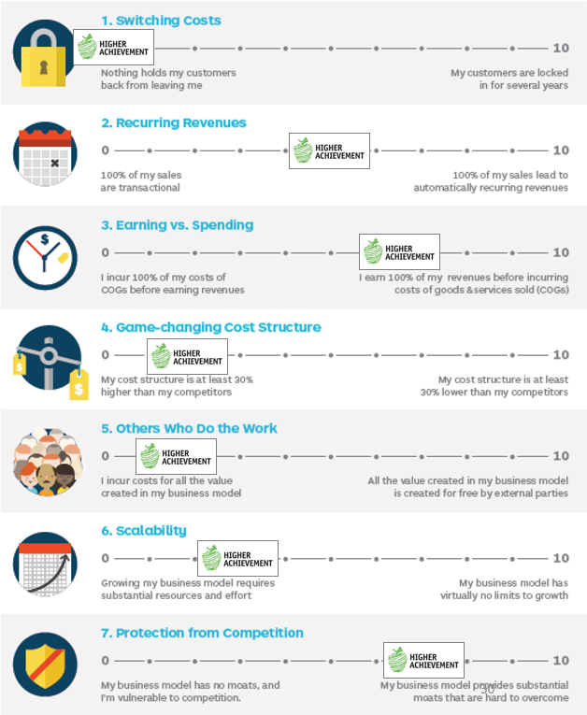Considering aspects of what makes the HA model unique, we asked HA to reflect on a few elements of the organization’s financial model using a for-profit-focused tool, shown in Figure 3[12]. Of note, HA called out the following aspects of their offerings:

**Figure 3.** HA 7 Questions to Assess Business Model Design

* HA provides direct services to students who can elect other options.
* Schools see results and are invested in long-term service partnerships.
* HA has a strong cash flow and an intentional approach to reserves and fiscal management.
* The model is more expensive than others, but also includes more hours and services for both students directly in the program and school-wide supports, and it is backed by results from one RCT and another RCT underway.
* Due to cost, staffing, and volunteers, the resources needed to scale are substantial — and the business model reflects this understanding.
* Few organizations provide the in-depth and evidence-based programs and supports of Higher Achievement throughout the year, every year.

Beyond the key items discussed above, there are a few additional elements HA cites as having been foundational in the organization’s achieved results and continued growth:

* HA strives to maintain and grow diverse sources of revenue, but with that comes different value propositions and activities (revenue is roughly 30% government, 35% foundation, 25% corporate, and 10% individual). HA is working hard to increase individual and corporate dollars, which are the most flexible and predictable.
* HA has established a chapter structure as one wholly-owned 501(c)(3), with four regions responsible for fundraising goals, staff hiring, management, and partner relations. The national office provides direct support and capacity-building to the regions, along with accountability for results and operational targets. HA has established a dashboard that directly connects program outcomes and financials, which has been effective at supporting both the mission and sustainability of operations.
* HA achieves tremendous results with the students they serve directly, but they also strive for greater impact in their regions and beyond. For example, they are advising the Aspen Institute’s Commission on Social, Emotional, and Academic Development on youth development and family engagement, and they have partnered with American Institutes for Research to develop an eight-part webinar series on how to practically engage middle school students in social and emotional learning, which they are using for their own staff and volunteers and intentionally sharing with other organizations. They also open up their volunteer and staff training in-service days to peer organizations, and more than 15 organizations have taken advantage of that opportunity to date, serving more than 20,000 students.

See Appendix 2 for a summary of Higher Achievement’s business model, which uses the Business Model Canvas framework[13].

# Conclusion

Financial sustainability is a core part of the overall sustainability of nonprofit organizations. Yet, organizations deal with an array of unique challenges when it comes to developing and executing a financial sustainability plan. Organizational issues range from procurement delays, having ample resources, and phasing out financial and programmatic support, to truly understanding the organization’s core business model. In order to achieve financial sustainability and, ultimately, sustain impact at scale, it is imperative that organizations map and understand their business models and take steps to develop and implement effective financial sustainability strategies accordingly.

# Appendix 1: ANet Business Model Canvas

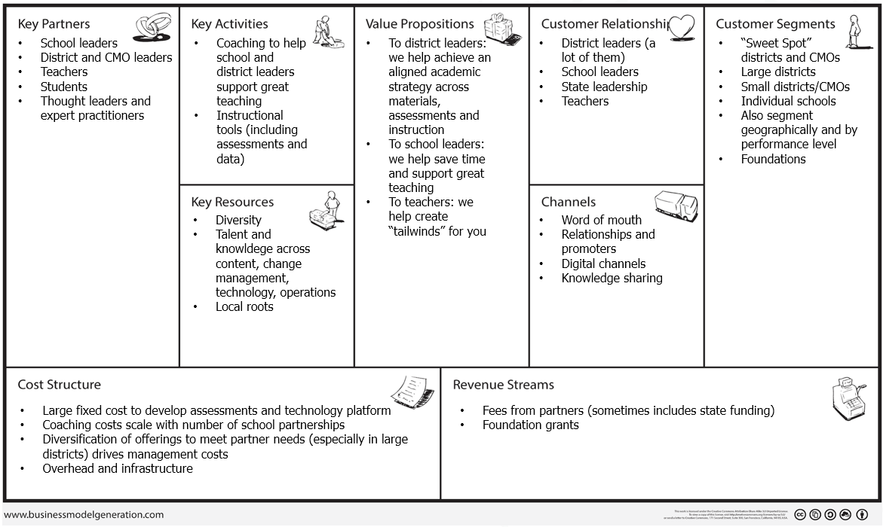

# Appendix 2: Higher Achievement Business Model Canvas

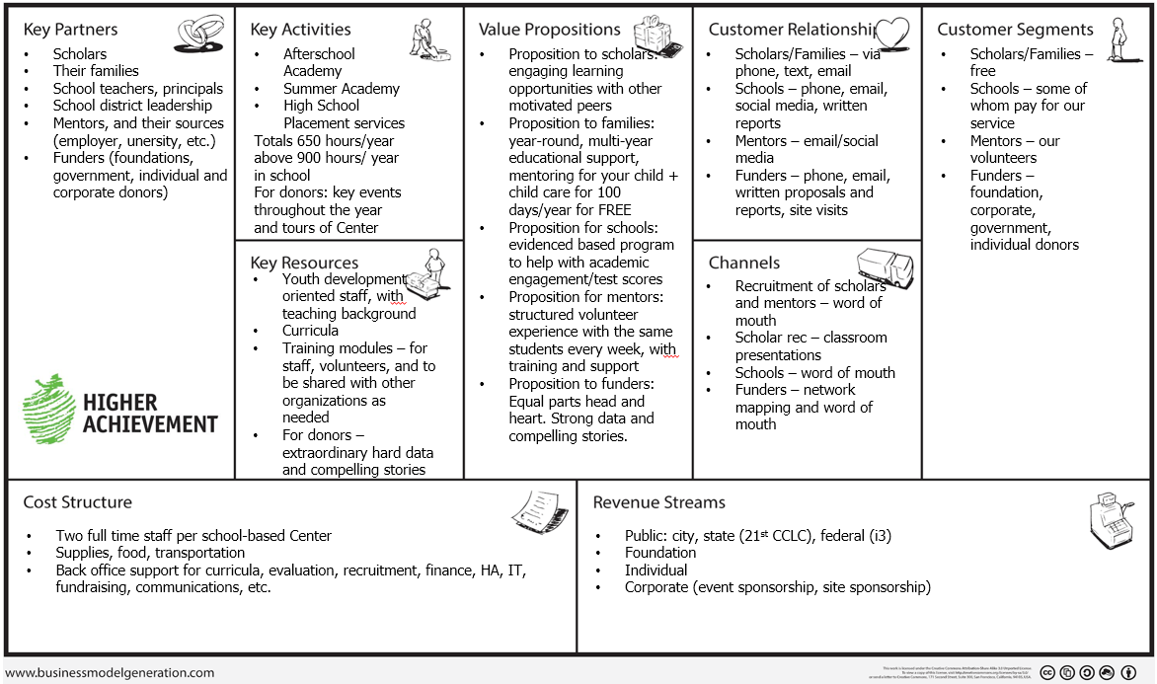

# Appendix 3: Higher Achievement Case Study

## CASE STUDY

### *Pressing Pause:* How one nonprofit and a lead funder tackled a crisis head-on and what they learned about scale, decision-making, and communication

By Lynsey Wood Jeffries and Dara Rose

*“Today, there may be no idea with greater currency in the social sector than ‘scaling what works,’”* wrote Jeffrey Bradach, of The Bridgespan Group.[14] Look no further than the 92 Investing in Innovation (“i3”) projects funded by the U.S. Department of Education[15] or the Social Impact Exchange[16] to see that the public sector and private philanthropy are driving nonprofits to scale. For many, scaling means replicating a program to more sites and serving more kids. Yet, on the road to scale, too many organizations confront pernicious funding cliffs and unbalanced spreadsheets, with too few talking with their boards, funders, and other nonprofits about it. As significant seed funding runs out, underlying financial instability is revealed. Perched on that precipice, funders often step away and the promising solutions fall off the cliff and disappear, along with those precious launch dollars. The following case describes Higher Achievement’s scaling effort, funding crisis, turn-around from the cliff, and successful new growth plan.

***2000-2009: Setting sights on evidence then national reach***

Since 1975, Higher Achievement has functioned as a local after-school and summer academic program for talented middle school students of color from poor neighborhoods in Washington, DC[17]. The program’s structure was somewhat flexible in the first 25 years, but consistently involved volunteers, summer learning, and homework help.

In 2000, the organization faced financial hardship, and all but three board members wanted to close shop. Those three committed board members laid off all staff, paused operations for six months, and hired a community organizer, Maureen Holla, to serve as a turn-around executive director. Holla agreed to the job on the condition that the organization reorganize as a rigorous, outcomes-oriented, national demonstration model to prove that after-school and summer learning can help close the achievement gap. During six months of planning, Holla and the remaining board members developed the core elements of the current program[18]. After five years, the organization was consistently demonstrating strong internally measured outcomes (grades, test scores, school attendance, and high school placement), yet skeptics discounted the value of the program, attributing the gains to selection bias. To answer the skeptics’ questions and empirically demonstrate impact, the organization embarked on a randomized controlled trial study in 2005, which only 2% of nonprofits in the country have performed. This was a gutsy move. Higher Achievement’s annual budget was about $900,000 – and this study cost $4 million.

By embarking on this study, Higher Achievement caught the eye of several national foundations, including Atlantic Philanthropies, which invested in the study, and then in business planning for national growth. Atlantic enlisted the consulting group Bridgespan in 2006 to lead a planning process to replicate Higher Achievement’s program in additional cities. The focus on geographic expansion as the primary means to make a social impact is not uncommon for nonprofits. Scaling expert Gregory Dees writes, “Most social entrepreneurs are inspired to scale out because they see a need for their innovation in other communities.”[19]

While the growth planning process was quite detailed, several operating assumptions were left unchallenged. For example, the plan assumed a 500 students cap in future cities because it seemed to be the natural ceiling for mentor recruitment in Washington, DC. And “scale” was defined somewhat arbitrarily as serving 5000 students nation-wide. Therefore, the plan set a goal of “5,000 youth in 10 cities” by 2017 and focused on issues related to city selection and organizational expansion – like governance and program fidelity. Of note, during this expansion planning, Maureen Holla moved overseas and the D.C. based board hired Richard Tagle to lead and expand the organization, leveraging his national education network[20]. Despite this hire, several board members resisted national expansion, given the continued need in Washington, DC.

In the first several years, funders enthusiastically received and generously supported the scaling plan. From 2006-2009, the organization raised $9.6 million in philanthropic growth capital, ten times the organization’s 2004 operating budget. These investments were principally comprised of $3 million each from Atlantic Philanthropies, The Wallace Foundation, and Altria, and $500,000 from Jack Kent Cooke Foundation. During those years, the organization transferred critical functions like finance, human resources, technology, curricula, and communications from the flagship D.C. office, now an “affiliate[21],” to a newly-created national office to effectively manage shared services across multiple cities and achieve economies of scale. Growth capital supported critical organizational infrastructure development (e.g., improved website, intranet, and management information system), codification of the program design, and development of quality assurance and training tools. The national team aimed to raise a total of $14 million in growth capital to support this phase of growth[22]. This would position Higher Achievement to support branching with high quality and fidelity to the program model in four additional cities. Importantly, this growth capital also funded the addition of new staff positions, which were an ongoing expense.

***2009-2012: The cart gets in front of the horse***

From 2009-2012, Higher Achievement grew from one city to four cities, opening affiliates and serving students in Baltimore (2009), Richmond (2011), and Pittsburgh (2012). During this period student enrollment also increased from 500 to 790.

This expansion was feasible, despite the economic recession, because of the growth capital that had already been raised. Yet no significant, new national dollars had been confirmed from 2010-2012, making the $14 million goal out-of-reach, as was clear to board and staff in monthly finance reports. In 2012, only the Washington, DC affiliate was financially and programmatically strong. This affiliate consistently served more than 500 scholars, produced strong academic results and significant cash surpluses, which covered the growing deficit of the national office caused in part by increasing national personnel costs. From 2009 to 2012, national staff had increased from six people to a team of 17 people[23]. In essence, Higher Achievement had bulked up its staffing structure to support dramatic projected growth, but actual growth was slower than originally planned. Thus, the near-term cost per pupil spending was high and unsustainable.

As is common, the newer affiliates struggled with program quality and covering the direct costs of programming with locally-generated revenue[24]. Also, the expectation that affiliates would pay 10% of operating expenses each year to support “back office” functions at the national office didn’t materialize. In the 2011-2012 fiscal year, enrollment was only: 110 in Baltimore, 50 Pittsburgh (it had just launched) and 130 in Richmond. The total cost of serving these 290 students was $1.9 million, a cost per student of $6550.

|  |  |  |  |
| --- | --- | --- | --- |
| Cities | Local Revenue in  FY 2011/12 | Number of Scholars | Cost/Scholar |
| DC Metro – opened 1975 | $2.8 million | 500 | $5600 |
| Baltimore – opened 2009 | $800,000 | 110 | $7200 |
| Richmond – opened 2011 | $800,000 | 130 | $6150 |
| Pittsburgh – opened 2012 | $500,000 | 50 | $10,000 |

**September 2011 – August 2012: Panic, Crisis, and Resolution**

In September 2011, the organization reported a shortfall of $1.35 million, which was covered by the remaining dollars from the growth capital. Also at this point, the board executive committee began weekly conference calls with Tagle, to check in on finance and discuss fundraising. As the weeks and months passed, the tension mounted. The staff felt that the board was not engaged sufficiently in fundraising, and the board executive committee (especially the Treasurer – a retired accountant) was focused on contingency planning. This reflected the Board’s preference for cost cutting over utilizing an established line of credit to balance the year-end budget, signaling their skepticism of the organization’s ability to generate new revenue after funding that was reported as probable did not materialize. In January 2012, the DC affiliate’s local advisory board learned of the financial crisis, and mobilized to prompt action from the national board and staff. The DC advisory board sent a strongly-worded letter to the national board and staff leadership, and there were discussions of the DC affiliate separating from the national entity[25].

During this period, Dara Rose, Higher Achievement’s program officer at The Wallace Foundation, redoubled her attention to the financial well-being of the organization. She required monthly fundraising updates making the point that ‘proof of impact doesn’t equal proof of sustainability.’ Yet, staff and board leadership believed that the promising initial findings from the RCT study in 2011 would lead to new, significant national grants within six months. The organization undertook major efforts to promote the RCT study results, and launched varied fundraising efforts, including a board-led campaign to raise $1 million, despite the fact that for the past several years, annual board giving typically totaled $120,000.

Yet by April 2012, no new significant dollars had been secured and only $40,000 had been contributed by the Board. Without major change, the organization would have exhausted all unrestricted cash and ended the fiscal year with a $500,000 deficit. Concerned, Rose requested an in-person meeting with the CEO and board leadership to discuss contingency plans. Simultaneously, the board was demanding dramatic cost cutting. *“Higher Achievement’s program outcomes were very strong, but the growth plan was too aggressive and the cost structure became too bloated.   I had worked with good companies to ‘right the ship’ after 2007, and knew that with immediate, decisive action and strong leadership, we had a chance of saving this organization too.” Sameer Bhargava, Managing Director of Carlyle and Board Vice Chair at the time.*

Ultimately, on April 15, 2012, the National CEO stepped down and the board asked the executive director of the DC affiliate, Lynsey Wood Jeffries, to step up to serve as the CEO. She agreed to serve in both capacities for six months, while coaching her deputy to step up to become the local DC executive director.

Given the upheaval, Rose’s site visit the next day (April 16th) took on a new level of importance. Board and staff leadership attended the meeting and began a series of transparent conversations with her about how they would end the fiscal year with a balanced budget without compromising the quality of the programming or exiting any of the four current cities. Higher Achievement accomplished this goal primarily by reducing staff farthest away from the “point of service.” On Friday, April 19, five days after Jeffries stepped up to CEO, she was forced to address the looming deficit by laying off 10 talented, committed national staff members. Importantly, two board members, Sameer Bhargava and Annie Czerwinski (a nonprofit talent recruiter), joined the individual lay-off meetings, which clearly signaled board leadership of this process. With a staff of just seven people representing 41% of what the national office had been, Jeffries led the team to prioritize ruthlessly. They focused on two main objectives: program quality and financial sustainability. The remaining staff included the three-member finance team (fully in tact), one development director, one program director, one human resource and administrative manager, and the CEO.

Remaining national staff put many exciting projects on hold, such as press outreach, STEM curricula development, advocacy on federal policy, and new program partnerships. Jeffries also halted discussions of expansion to Nashville, the likely location of the anticipated fifth affiliate, and due diligence for future cities. Jeffries opted to sacrifice these ‘bells and whistles,’ and instead placed her bets on scholar outcomes and data-driven programming. This meant relying on the talents of affiliate staff, clearing away distractions, and getting back to basics. Every month, Jeffries met with each affiliate executive director to discuss progress on scholars’ grades, test scores, attendance and high school placement while also very closely monitoring expenses and newly conservative revenue projections.

Next, she set up one-on-one meetings with each board member to hear their perspectives and gauge why, despite their best intentions, the financial troubles were not identified and addressed much earlier by the board and determine who was willing to step up and ensure the organization’s financial viability. After those meetings, a few board members stepped down, and three new directors joined the board who had been generous supporters of the DC program. Further, Patti Cook’s term limit as board chair was approaching and after the finances were in order, she decided to step down from the board. In August, Jeffries asked Sameer Bhargava if he was interested as serving as the next board chair, and in September the board voted him into the role. “*I knew that saving Higher Achievement would make a measurable difference for many deserving students, so I stepped up for the challenge.” Sameer Bhargava, Board Chair.*

In the first eight months, Jeffries and her senior team met with their board finance committee every other week to carefully monitor the financial situation and numbers of scholars served. After each biweekly finance committee meeting, Jeffries held conference calls with Rose to transparently share running budget updates and year-end projections. The new fiscal discipline paid off and this $6 million organization ended fiscal year 2012 with a $62,000 surplus in unrestricted net assets and incurred no debt.

***2013: Mapping a plan for the future: go deep and tackle sacred cows***

With the crisis abated, Jeffries embarked on a new strategic planning process with Community Wealth Partners. This planning process was a risky choice given limited resources. However, Jeffries aimed to rebuild cohesion after the downsizing, buoy optimism among employees, and develop a clear plan that would reenergize supporters and leverage Higher Achievement’s strengths in the current economic and educational landscape.

“*Through our market research we found that key stakeholders valued the program’s strong base of evidence and culture of rigor, but questioned the organization’s ability to realize large-scale social impact. We partnered with the Higher Achievement team to challenge critical assumptions and to reframe their strategy around a bold, long-term goal.” Amy Celep, CEO Community Wealth Partners*

After listening to funders, school partners, and other internal and external stakeholders, Higher Achievement determined a new three-tiered approach to scale:

1. Serve core scholars from a single school with its intensive proven model,
2. Impact all students in that school with targeted services, and
3. Leverage influence in existing affiliate sites for city-wide improvement and collective impact.

To achieve this new impact, the organization had to rethink its sacred cows. The Wallace Foundation served as a key partner in this rethinking process by asking hard questions and sharing examples from other grantees. Rose and Jeffries talked at length about how the new plan could reposition Higher Achievement as a powerful expanded learning partner for schools[26].

Sacred Cow #1: magnet school recruitment model

For years, Higher Achievement had delivered its programming through a magnet approach. Achievement Centers, hosted by schools afterschool and in the summer, served students from up to 20 schools with as few as five students from the host school enrolled in the Achievement Center. While this approach offers important social benefits, it does little for the host school.

Over the next three years, Higher Achievement will expand in a “zone approach” that concentrates impact in bounded environments, such as a single school, in contrast to the magnet approach. Higher Achievement will transition from a traditional out-of-school time program into an expanded learning time model, partnering closely and flexibly with its hosting partner schools to achieve shared goals. By 2016, Higher Achievement will open up to seven new Zones, growing the roster of scholars by 70% - directly serving at least 1,700 students – or approximately 30% of the host schools’ student rosters.

Sacred Cow #2: uniform intervention strategy with high dosage

In addition to the students in the intensive program, up to 7,000 other students will be impacted by school-wide services. A menu of discrete services, such as homework help and high school placement counseling, will be offered to zone school partners, building on Higher Achievement’s core competencies and complementing other programs in the school, such as City Year and Communities in Schools.

Sacred Cow #3: national expansion

Through this turn-around, the organization shifted its definition of scale. Instead of merely counting number of cities (10) and number of students (5000), Higher Achievement now aims for school-wide and city-wide improvement that should actually impact 7000 students by 2016 –in just four cities. The logic behind these new figures is that by reaching 30% of the students within the toughest middle schools in each district, Higher Achievement believes it can hit a “tipping point” that can improve the overall school climate, and ultimately improve district high school graduation and college matriculation rates.

Higher Achievement’s shift to a single-school model also supports financial sustainability. Recruiting students within a single school lowers their cost-per-scholar, reducing transportation, data collection, and other costs. Additionally, this shift opens two potential revenue streams: school-based financial contributions and corporate sponsorships. *“I see Higher Achievement as a strategic partner for our school’s turnaround.  They are serving a meaningful percentage of our students, and also helping us attract and retain strong students in the school.  Given this value, I have devoted funds to support Higher Achievement in my school.* – Abdullah Zaki, Principal of Kelly Miller Middle School in Washington DC.

**2013 – today: Fiscal Discipline, Tools, and Programmatic Strength**

In 2013 after the strategic planning had concluded and goals with performance measures were agreed upon, Higher Achievement partnered with new board member and CEO of Censeo Consulting –, to develop a pro-bono[27] financial model to undergird the strategic plan. This new tool connects, in a highly automated way, program-level outcomes[28] with quarterly financials. This tool makes all data more transparent and useable, and saves about six weeks of the National Program Director’s time annually. In fact, front-line staff share this data with scholars’ families to demonstrate the importance of attendance and cost of absence, both on their child’s learning and Higher Achievement’s finances.

*“Goal setting, planning and decision making that incorporate finance, development and program staff are key drivers to success and populating and using performance dashboards can be a big challenge for clients nonprofits,”* shares Founder and Managing Director of Fiscal Management Associates and long-time expert and advisor to non-profits, Hilda Polanco, CPA, CGMA, CCSA®. *“The fact that Higher Achievement's performance model connects the accounting and program data systems is a key part of its success. Automation is crucial because otherwise time consuming data entry can make staff lose steam. As nonprofits rapidly grow, they are well served to have a similar thought process in place; technology can be a driver of efficiency to help them use the right real time data."*

A year later, the organization is even stronger financially and programmatically. The organization ended FY2013 with a surplus of $400,000+, stronger programmatic outcomes, and serving more scholars than ever before.

|  |  |  |  |
| --- | --- | --- | --- |
|  | **FY 2011 (9/1/2010 – 8/30/2011)** | **FY2012 (9/1/2011 – 8/30/2012)** | **FY 2013 (9/1/2012 – 8/30/2013** |
| Change in Net Assets | -$2.9 million | +$62,000 | +433,000 |

Now, with final results from the randomized-controlled trial study, published by MDRC, the organization is poised to fulfill its strategic goals. Schools are competing to become partners, and new funding is secured.



*“Thanks to new national leadership, our Baltimore Centers now focus on long-term program sustainability, as well as excellence in program outcomes.  We recently celebrated our fifth year in Baltimore city.  Seventy four percent of our scholars have improved their standardized test scores or maintained advance or proficient in math and reading. We look forward to sustainability serving generations of scholars.” Erin Hodge-Williams, Executive Director, Higher Achievement - Baltimore.*

### Take-aways for the Field

**To meet affiliate needs, functional centralization must be dynamic:**

When scaling, organizations must constantly revisit their core assumptions to test relevance in the local context. Further, internally, organizations should question the efficacy of centralized and decentralized systems and staff functions. For example, in some cases, functions like fundraising may be more efficiently administered centrally, but funding relationships may be more effective at the local level. Similarly, while program fidelity is a chief concern of a national office charged with replication, instructional expertise that is attuned to school and district priorities reside at the local level. This difficult balance organizationally can be achieved through the creation of feedback loops and distributed decision-making.

**Re-defining scale: is more always more?**

While there are a variety of ways to make a large scale impact, a good deal of non-profit attention is focused on program expansion. “Expansion refers to taking a model to scale by increasing the scope of operations of the organization that originally developed and piloted it. The most common form of expansion is growth, which normally occurs by branching out into new locations or target groups.”[29] Accordingly, Higher Achievement staff and board raised funds and focused efforts for almost five years on building the centralized capacity and infrastructure to manage multiple sites.

However, Northwestern University professor at the School of Education and Social Policy Cynthia Coburn points out that scaling up is not simply additional sites, but that consequential change is comprised of four dimensions: depth, sustainability, spread, and shift in reform ownership.[30] This model is much more consistent to Higher Achievement’s new strategic growth plan.

**Managing growth: when do you pull the trigger on scale, and when do you pause?**

Higher Achievement did conduct robust due diligence, which indicated need and demand for their growth to new cities. However with substantial early growth capital raised by headquarters brought to bear, the local financial commitment needed for long-term expansion and sustainability were not truly confirmed at the point of entry. Therefore, while painful, it was not surprising and actually quite healthy that Higher Achievement paused three years out in their expansion effort and modified their expansion goals.

**The risks of growth capital and unrealistic funding models**

Raising growth capital is not the same thing as developing and testing a viable financial model for service delivery and on-going operations. Importantly, when growth capital is used to support ongoing salaries, the sustainability of those funds should be vigorously challenged. The case of Higher Achievement is cautionary in that big investments masked financial instability. It took longer than expected for each new city to reach full enrollment and financial sustainability. Thus, the growth capital did not last long enough.

So a financial crisis was borne in the national organization’s first years of expansion because it was too top heavy given the enrollment figures and limited revenue generation following the growth capital infusion. Non-profit management and social policy expert Peter Frumkin suggests that financial strength is also a key dimension of an organization’s scale, and that few nonprofits that have gone to scale in a way that is consistent with this model.[31]

**Staff and board must face a looming funding cliff head-on, and early**

As part of its fiduciary oversight responsibilities boards of directors must interrogate revenue and growth projections, however, boards only know as much as they are told on staff-led funder cultivation. Conservative and clear categorization of revenue (and its likelihood) is needed. Financial statements can clearly outline upcoming challenges and it is also important to have and listen to diverse voices on the board.

**Transparent and robust communication necessary - between investors and nonprofit CEOs**

It also behooves growth investors to go beyond an annual review of a grantee’s 990 form or audited financial statements. Investors should regularly monitor of cash flow and scrutinize the financial assumptions of the program’s growth model, including insistence on the use of contingency and multi-year planning.

Regular contact between growth investors and social entrepreneurs is therefore critical. Executives should be proactive, seeking early insights from funders and listening to their concerns when raised. This transparency builds the trust that is required to sustain funding partnerships through changes in goals, strategies, leadership and dips in financial performance. This communication is often uncomfortable. In the nonprofit sector, we take as sacred our common commitment to public good and appreciate the mission-driven nature of our shared compact. But that is not enough. In the end, questioning assumptions, revisiting goals, and focusing on both program impact and the bottom line are needed for social innovations to scale.

**Release Date:** May 15, 2019

*This publication was prepared by the Education Innovation and Research (EIR) Program Dissemination Project. The project is conducted by the* [*Manhattan Strategy Group*](http://www.manhattanstrategy.com/)*, in partnership with* [*Westat*](https://www.westat.com/) *and* [*EdScale*](http://www.edscalellc.com/who-we-are.html)*, LLC, with funding from the U.S. Department of Education’s* [*Office of Innovation and Improvement*](https://innovation.ed.gov/what-we-do/innovation/education-innovation-and-research-eir/) *(OII), under Contract No. ED-ESE-15-A-0012/0004. The project team provides technical assistance to all grantees of the Investing in Innovation (i3) and EIR programs to increase their sustainability, scaling, and dissemination capacity; increase the widespread adoption of grantees’ evidenced-based programs and practices; connect grantees with thought leaders and practitioners in the larger education community; conduct cross-project analyses of i3 and EIR grantee research on effective practices for high-need (e.g., English learners) students and schools (e.g., rural); and broadly translate and disseminate i3 and EIR research to practice. This publication does not necessarily represent the positions or policies of the U.S. Department of Education, and no official endorsement by the U.S. Department of Education should be inferred.*

**Contributors**

Tom DeWire (EdScale, LLC), Deqa Farah (MSG), and David Silverman (MSG). Special thanks to ANet (Carter Romanski) and Higher Achievement (Lynsey Jeffries and Mike Di Marco) for their willingness and thoughtful reflections to share their lessons learned with others.

**Suggested Citation**

DeWire, T., Farah, D., & Silverman, D. (2019). *Financial sustainability: Earned, not given*. Bethesda, MD: Manhattan Strategy Group. Retrieved from <https://i3community.ed.gov/news-articles/2384>

Copyright © 2019 by the Manhattan Strategy Group. Material may be duplicated with full attribution.

1. Zarrow, Joel (2018, July). *Financial Sustainability and Business Planning.* Presentation by CEO of Children’s Literacy Initiative at the i3/EIR Project Director’s Meeting, Washington, D.C.
2. The Community Tool Box. (n.d.). *Welcome to our community*. Retrieved from <https://ctb.ku.edu/en/table-of-contents/finances/grants-and-financial-resources/financial-sustainability/main>
3. Zarrow, Joel (2018, July). *Financial Sustainability and Business Planning.* Presentation by CEO of Children’s Literacy Initiative at the i3/EIR Project Director’s Meeting, Washington, D.C.

   Coburn, C. E. (2003). Rethinking scale: Moving beyond numbers to deep and lasting change. *Educational Researcher, 32*(6), 3–12.
4. Coburn, C. E. (2003). Rethinking scale: Moving beyond numbers to deep and lasting change. *Educational Researcher, 32*(6), 3–12.
5. EdScale, LLC, Westat, & Education Development Center. (2017). *Scaling up evidence-based practices: Strategies from Investing in Innovation (i3)*. Retrieved from <https://i3community.ed.gov/system/files/resource_files/2017/scaling_up_evidence_based_practices_i3.pdf>
6. Bowman, W. (2011). Financial capacity and sustainability of ordinary nonprofits. *Nonprofit Management and Leadership, 22*(1), 37–51.
7. Meehan, W. F., & Jonker, K. S. (2018). *Engine of impact: Essentials of strategic leadership in the nonprofit sector*. Stanford: Stanford University Press.
8. Strategyzer AG. (n.d.). *The Business Model Canvas*. Retrieved from <https://strategyzer.com/canvas/business-model-canvas>. *Seven questions to assess your business model design*. Retrieved from <https://assets.strategyzer.com/assets/resources/7-questions-to-assess-your-business-model-design.pdf>
9. Strategyzer AG. (n.d.). https://www.strategyzer.com/
10. Strategyzer AG. (n.d.). *Seven questions to assess your business model design*. Retrieved from <https://assets.strategyzer.com/assets/resources/7-questions-to-assess-your-business-model-design.pdf>
11. Strategyzer AG. (n.d.). *The Business Model Canvas*. Retrieved from <https://strategyzer.com/canvas/business-model-canvas>
12. Strategyzer AG. (n.d.). *Seven questions to assess your business model design*. Retrieved from <https://assets.strategyzer.com/assets/resources/7-questions-to-assess-your-business-model-design.pdf>
13. Strategyzer AG. (n.d.). *The Business Model Canvas*. Retrieved from <https://strategyzer.com/canvas/business-model-canvas>
14. “Scaling Impact,” Stanford Social Innovation Review, Spring 2010
15. The purpose of i3 is, “to generate and validate solutions to persistent educational challenges, to **support the expansion** of effective solutions across the country, and to **serve substantially larger numbers of students**,” (bolded emphasis added), Update on the Investing in Innovation (i3) Fund, July 2013, Ed.gov
16. “The Social Impact Exchange creates the conditions for ***breakthroughs to go big*** in order to deliver impact where it is needed most. Together, our members are building a marketplace to scale-up solutions to significant social problems,” www.socialimpactexchange.org/exchange/about-us/overview. The Social Impact Exchange was launched by the [Growth Philanthropy Network](http://www.growthphilanthropy.org/) [(GPN)](http://www.growthphilanthropy.org/), in partnership with Duke University - [Center for Strategic Philanthropy and Civil Society (CSPCS)](http://cspcs.sanford.duke.edu/) and its [Center for the Advancement of Social Entrepreneurship (CASE)](http://www.caseatduke.org/).
17. Founded by an inspiring teacher, Greg Gannon, at Gonzaga, an all boys Jesuit high school in DC.
18. The program totals 650 hours per year. Traditional program elements include: Six-week summer academy (40 hours per week with four subjects and project-based learning + overnight college trip), after-school program 3 days per week until 8pm with homework help, arts/sports, academic mentoring, and high school placement advising.
19. “Pathways to Social Impact: Strategies for Scaling Out Successful Social Innovations,” Gregory Dees, Bath Battle Anderson and Jane Wei-Skillern, CASE Working Paper Series No. 3, Center for the Advancement of Social Entrepreneurship
20. Richard was previously the Chief of Staff for the Public Education Network. Maureen continued to serve as an advisor to the board and CEO from overseas, until 2009.
21. Higher Achievement is one wholly-owned legal entity, but refers to each new city’s branch as an “affiliate”.
22. To meet this goal, the organization also centralized development staffing at the national office, a decision that has since been reversed after push-back from the affiliates that believe that fundraising should be done by local staff. The headquarters supports these efforts and only leads national fund development.
23. Six of these staff members were initially part of the local DC team.
24. The financial assumptions of the 2006 expansion plan set a guideline for upfront local investments of at least $1 million before launching a new city. While Richmond was able to use Altria funding to cover their local investment goal, no other affiliates were able to do so with local dollars.
25. This letter was one example of an ongoing discussion about the value of the national office to affiliates, compared to its cost.
26. There are a variety of efforts nationally experimenting and demonstrating new models for intensive and integrated school-community partnerships. As schools, particularly those in “turnaround” mode, are experimenting with lengthened school days and years, some are maximizing human and financial resources by collaborating with nonprofit program providers. Two illustrative partnerships are The After School Corporation’s ExpandED program ([www.tascorp.org](http://www.tascorp.org)) and Citizen Schools’ Expanded Learning Time effort ([www.citizenschools.org/about/model](http://www.citizenschools.org/about/model) ).
27. Valued at $310,000.
28. KPIs include school grades, test scores, attendance
29. “Scaling Up – From Vision to Large-Scale Change: A Management Framework for Practitioners,” Second Edition, 2012, Management Systems International, page 10
30. “Rethinking Scale: Moving Beyond Numbers to Deep and Lasting Change,” Coburn, Educational Researcher, Vol. 32, No.6, August/September 2003
31. “The Five Meanings of Scale,” HFRP The Evaluation Exchange, XV 1, page 7