Note: Only approved applications, fund requests and application supplements are viewable to the public. Versions and requests that are still in the creation and approval process will not be publicly accessible.

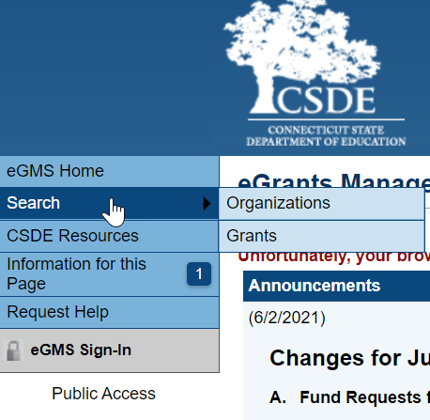
- Go to the eGMS Home Page https://connecticut.egrantsmanagement.com. (This page also includes links to training videos and guides that will assist you in navigating the eGMS site.

- On the upper left menu, select Search. You can search for a specific organization to view all their approved applications, fund requests and application supplements or you can search for a specific grant and see all the organizations with an approved application for the grant.

To view approved applications for a specific organization or district
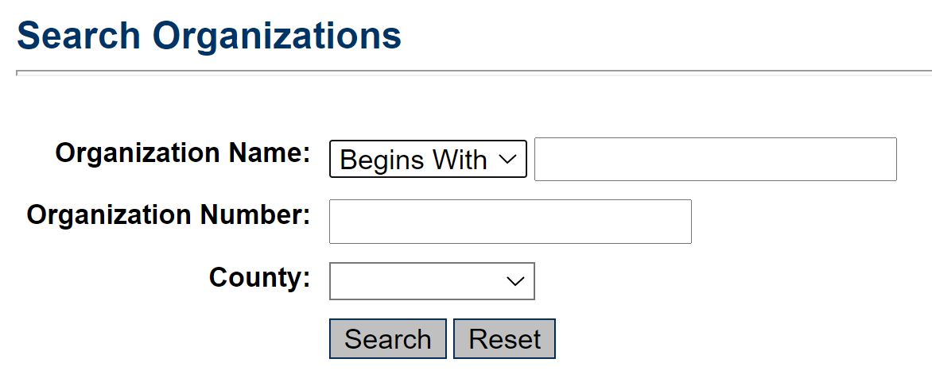
- Select Organizations from the submenu.

- Enter the name or part of the name and click Search.

- In the search returns, move to the column heading “Function” and select FA for Funding Application.

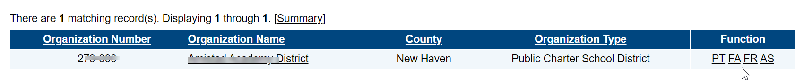
- In the search returns, move to the column heading “Function” and select FA for Funding Application, FR for FFuund Requests, and AS for Application Supplements.

For Funding Applications (includes program details and budgets)

- On the Funding Applications page, select the Fiscal Year. (2021 refers to the 2020-2021 fiscal year)

- Click on the grant name to open it.

- Instructions for navigating within a grant can be found on the eGMS Home page in the Video and Training links section.

For Fund Requests (Expenditure Information)
- Click on FR
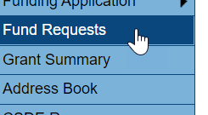
- Click on the Fund Requests menu item.

- Select ALL for fiscal years and ALL for Funding Applications
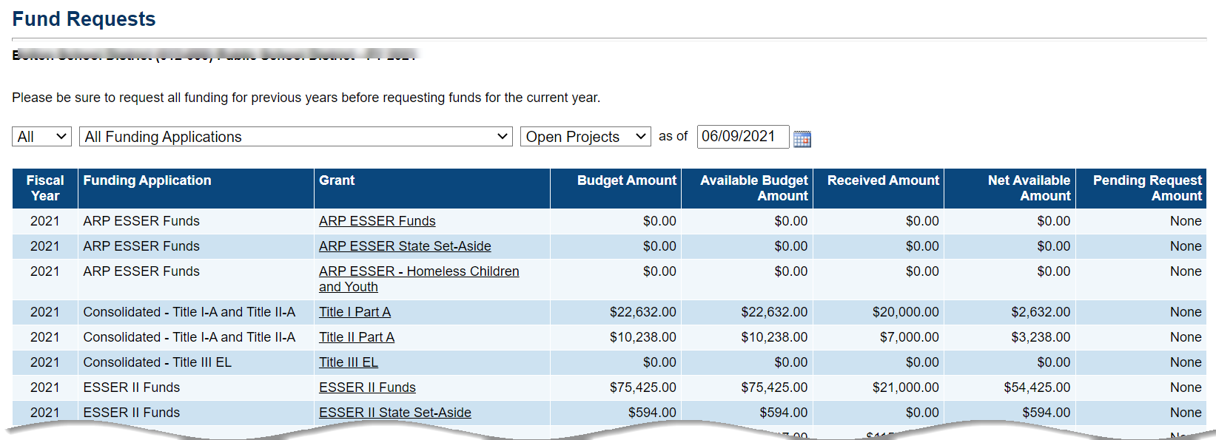
- Select the desired funding application taking you to the Project Summary page.
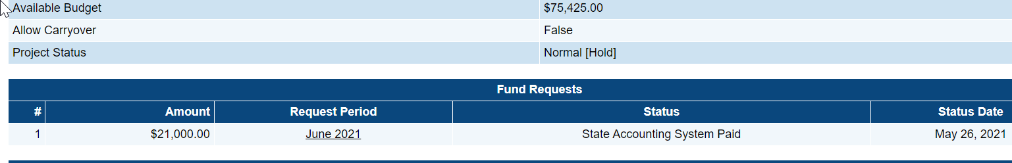
- Midway down the page are the Fund Requests created for the grant, click on the Request Period to open the desired fund request.

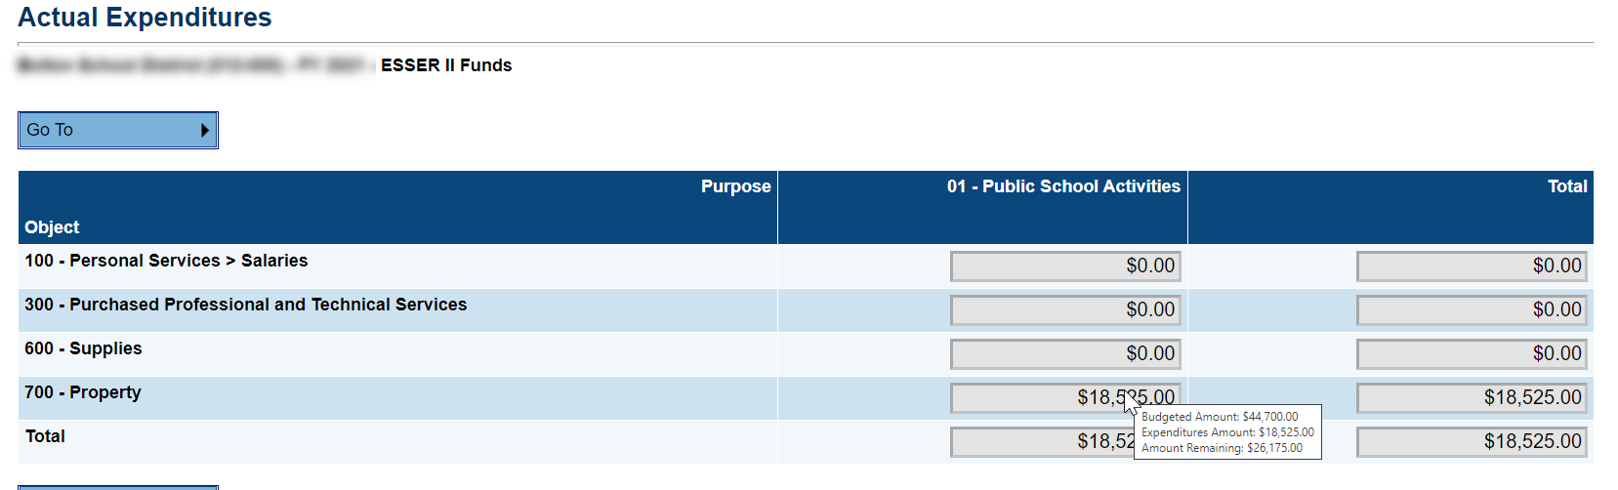
- On the Actual Expenditures page, hover over the fields to see the budget and the expenditures for that object code to date. Note: Actual Expenditures are only requried to be updates once a quarter.

To view all applications for a specific grant
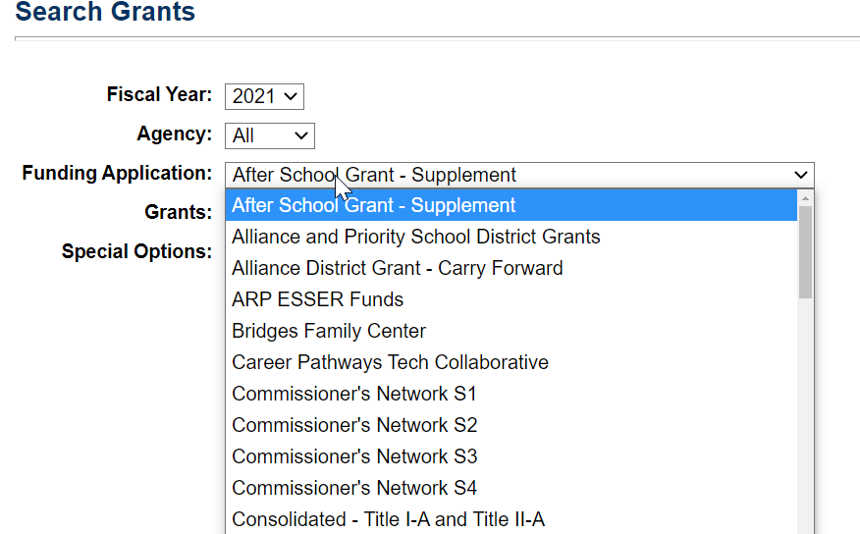
- Select Grants from the submenu.

- On the Search Grants screen, select the Fiscal Year, the Funding Application and the Grant. While the majority of funding applications contain only one grant, a few will contain multiple associated grants. The fiscal year indicates the ending period of the grant. (2021 is for fiscal year 2020-2021)

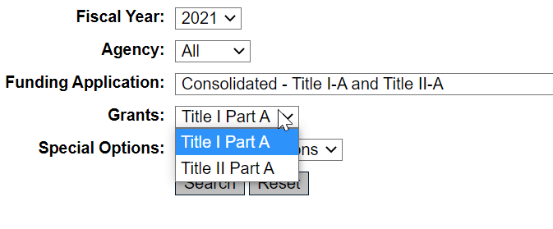

- The search returns will include organizations that have an approved application for the funding application selected.

- Click on the organization name to open the grant selected.
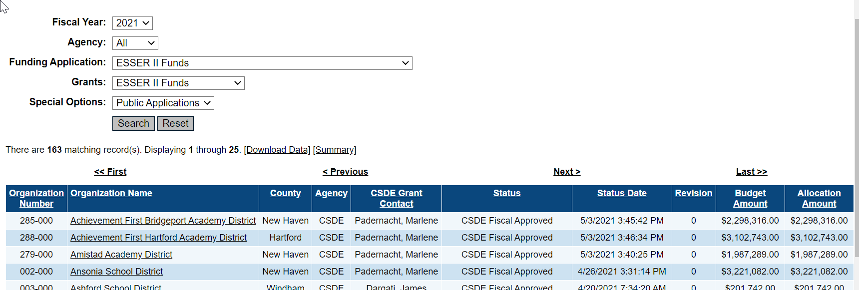

- Instructions for navigating within a grant can be found on the eGMS Home page in the Video and Training Links section.

