MOE Waiver Request Attachment
- Description of the extent to which the State experienced fiscal burdens in preventing, preparing for, and responding to the coronavirus and an explanation of how those fiscal burdens affected the State’s ability to maintain fiscal effort (e.g., the status of and any changes to the State’s rainy day fund, whether the State experienced a decline in revenues, or an increase in other emergency expenses resulting from the pandemic, such as expenses related to health care, unemployment insurance, or support for small businesses)
In North Dakota, state and local government took very limited measures to restrict business activity during the early months of the pandemic, which lessened the negative economic impact of COVID-19 on businesses and citizens. The state’s two-year budget period ending June 30, 2021, showed a modest shortfall of $44 million, or 2.4% for sales and use tax when compared to the original biennial forecast for the 2019-21 biennium (July 1, 2019 through June 30, 2021), indicating limited impact on taxable business activity and consumer spending. The most significant impact to North Dakota government revenues was related to oil and gas extraction and production taxes where the state experienced a significant shortfall compared to the original pre-pandemic forecast. Using the revenue definitions and calculation methodology submitted for the U.S. Department of Treasury for the State Fiscal Recovery Fund allocation through the American Rescue Plan Act, the state experienced a revenue shortfall of nearly $1.9 billion considering state fiscal year 2019 compared to calendar year 2020. For perspective, the state’s general fund budget for the 2019-21 biennium was slightly less than $5 billion. So, although there was minimal negative impact on general fund revenues, overall state revenues were significantly impacted.

Despite the significant revenue shortfall, North Dakota managed to increase nominal state support for higher education in state fiscal year 2022. In the context of overall state spending, there was a very slight decrease from the 2017-2019 average of 12.9% to 12.6% for state fiscal year 2022. There are two probable reasons for the immaterial percentage decrease in overall state support for higher education in state fiscal year 2022:
- The reduction in state revenues made it difficult for the state to increase funding for higher education beyond the small increase provided
- Funding for higher education is primarily driven by a legislatively adopted funding formula that bases funding allocations primarily on completed credit hours. The period upon which the 2022 funding formula is based experienced an enrollment decline and a corresponding decline in completed credit hours.
- Documentation and data supporting the description of the State’s fiscal burdens (e.g., revenue data, appropriation tables, unemployment statistics, etc.) including any State action that impacted State revenue (e.g., tax increases or decreases).
Although the state experienced exceptional revenue decline during the COVID-19 pandemic and managed to increase funding for K-12 and higher education, the percentage of overall state spending dedicated to higher education fell by a fraction of a percent. This is primarily a result of a state funding formula that is based on completed student credit hours. Even though the formula base rate was increased, the amount of completed credit hours did not result in an increase for higher education that exceeded the overall increase in state spending. Below is a description of the state higher education funding formula.
In 2013, the North Dakota Legislative Assembly approved the Governor’s recommendation to move the higher education institutions to a cost-based funding model that provides a fixed dollar amount per completed adjusted student credit hour. The process uses only successfully completed student credit hours (SCH), as measured at the end of each biennium. This performance model rewards institutions for students’ progress towards graduation/completion.
The legislature provides funding for base appropriations using a three-tiered approach: two-year colleges, four-year universities, and research institutions.
The formula is a matrix of weighting factors, or instructional program factor, developed based on the relative cost of instruction. As students move from lower division courses to upper division, professional level, and graduate level classes the delivery costs increase due to decreasing class sizes and higher faculty degree/experience requirements. To recognize the cost differences that occur as the student’s level of instruction changes within each discipline cluster, weighting factors were established, and applied system wide. This ensured that every course type was weighted appropriately, ranging from beginning level courses to a more expensive graduate student in a laboratory class.
Student credit hours are categorized according to Classification of Instructional program (CIP) code designations established by the U. S. Department of Education. CIP codes broadly define different academic disciplines, grouping them into discipline clusters, according to common characteristics. The use of CIP codes provided a consistent national standard for all institutions to follow.
The first step of the formula is to apply a credit completion factor. The credit completion factor increases as credit production decreases to account for the decreasing efficiencies of scale.
Next, the adjusted SCH for each institution are then multiplied by a per credit dollar amount established in statute to calculate an institution’s base operating appropriation. Capital investments are appropriated separately. The Legislative Assembly can appropriate additional amounts as necessary.
During the last few bienniums, many Higher Ed institutions have experienced a decrease in student enrollment. (See chart below, “Institutions of Higher Education Full-Time Equivalent Student Enrollments” for support.) As explained above, the state funding for ND institution is based on the Higher Education funding formula which is ultimately based on student’s credit completion factor. The decrease in student enrollments therefore has a direct effect on the decrease in state funding for Higher education in 2020 and 2021.
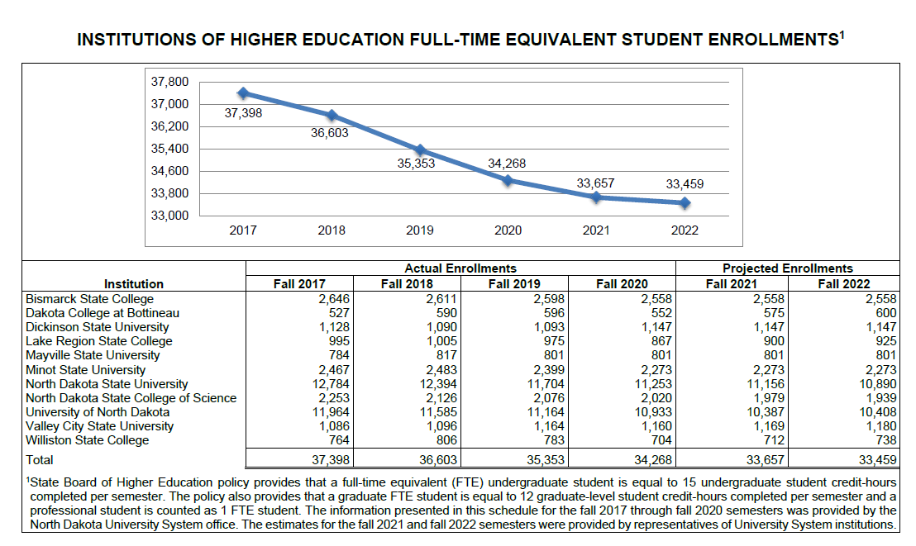

- Relevant factors to support the state of North Dakota request.
Has the State increased support for education?
Yes. The nominal amount provided for both K-12 and higher education was increased for the 2021-23 biennium. The funding formula base rates are per credit hour for the higher education formula and per weighted student unit for the K-12 formula. Both higher education and K-12 base formula rates were increased for the 2021-23 biennium. However, the reduction in student credit hours used to calculate the formula distributions to the institutions of higher education, combined with the increased formula base rate, did not result in an increase for higher education that was adequate to maintain the state effort as a percentage of overall state spending. In summary, overall state spending increased at a rate higher than the state support for higher education during fiscal year 2022.
Are there exceptional circumstances that caused the State to be unable to maintain support for education?
The state experienced exceptional revenue decline during the COVID-19 pandemic, primarily due to the unprecedented decline in oil and gas tax revenues, which are a critical component of the state’s overall revenue. However, the state’s lack of maintenance of effort for higher education during 2022 is more a function of the state’s formula than lack of overall resources. The state increased overall support for higher education from $660.5 million during the 2019-21 biennium, to $697.8 million during the 2021-23 biennium. The state support as a % of overall state spending fell by a very small amount, from a 2017-19 average of 12.9% to a 2022 level of 12.5%.
Has the State used or will it use ESSER, GEER, or Higher Education Emergency Relief (HEER) funding to replace State funding for education?
No. The state has not used any ESSER, GEER, or HEER funding to replace State funding for K-12 or higher education.

