ANY STUDENT WHO YOU BELIEVE MAY NEED EXTRA SUPPORT
Here are a few issues to look out for: Students who experience....
- Depression/ Irritability
- Anxiety
- Oppositional behavior
- Poor peer relationships
- Withdrawal/Isolation from others
- Tendencies to harm self or others
- Family and/or community violence
- Academic and/or attendance problems
- Significant change in behavior or functioning
- Bereavement and loss
- Abuse and neglect
- Exposure to substance abuse
- Homelessness
- Family stress
- Bullying
- School refusal
- Low self-esteem

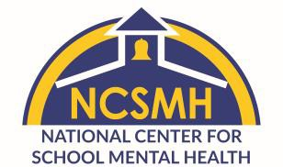
Please use the attached form to make a referral. This could be the first step in making a difference in your student’s life!
Drafted by the National Center for School Mental Health, 2019 www.schoolmentalhealth.org

