Connecting Root Cause Analysis to Evidence-Based Practices
Instructions:
Assume you are a district school improvement staff member, have just conducted a needs assessment and are now identifying an appropriate evidence-based practice (EBP) in a school identified for comprehensive support and improvement (CSI).
The needs assessment identified low reading achievement as a priority and a root cause analysis was then conducted using a fishbone diagram, leading to the results shown in the diagram on the next page.
Referring to the improvement areas (blue boxes) used to organize the root causes (white boxes), identify three online resources for EBPs that you haven’t used before, from the “Resources for Identifying Evidence-based Practices” handout. Search the resources for EBPs addressing some of the root causes. Try to find online clearinghouses or other resources that are searchable by improvement areas similar to those used in the root cause analysis below.
Indicate the online resources you identify below and respond to the reflection questions briefly, for further discussion during learning cycle 3. For additional information on using a fishbone diagram to conduct a root cause analysis see the Appendix.

Diagram. Root Cause Analysis Results for CSI School Needs Assessment (Fishbone Diagram).
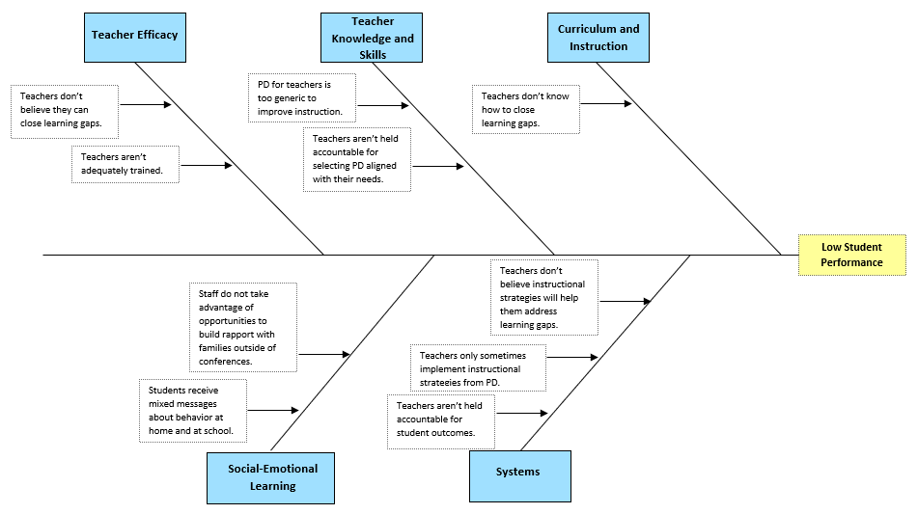
Activity & Reflection Questions
- Referring to the improvement areas (blue boxes) used to organize the root causes (white boxes), identify three (3) online resources for EBPs that you haven’t used before, from the “Resources for Identifying Evidence-based Practices” handout. Search the resources for EBPs addressing some of the root causes. Try to identify online clearinghouses or other resources that are searchable by improvement areas similar to those used in the root cause analysis.

Resource for EBPs | Improvement Area (resource) | Root Causes Addressed  By EBPs

- What were the strengths or weaknesses of any of the new clearinghouses/resources you explored, with regard to how you can use root cause analysis results to search them? Which resource(s) did you prefer and why? __________________________________________________________________________________________________________________________________________________________________________________
_________________________________________________________________________________________

- Were certain improvement areas (blue boxes) easier or harder to find EBPs for than others? What other relevant observations can you make regarding the connection between the root cause analysis results and the process of identifying EBPs?
________________________________________________________________________________________
________________________________________________________________________________________
________________________________________________________________________________________

- What type of root cause analysis is promoted or supported in your state model (e.g. Fishbone, “5 Whys”)? Do they include improvement areas or other categories that might help educators connect results to EBP resources? Are there other “connectors” between root cause analysis results and EBP selection in your state system? ________________________________________________________________________________
________________________________________________________________________________________

- How else might you align your state’s needs assessment process with resources for EBPs? ________________________________________________________________________________________
________________________________________________________________________________________

- What other challenges are your schools or districts having with the needs assessment process?
________________________________________________________________________________________
________________________________________________________________________________________

- How is your state supporting the needs assessment process and ensuring that it is connected to the selection of EBPs?
________________________________________________________________________________________
________________________________________________________________________________________

Appendix: Fishbone—Cause and Effect Analysis Protocol
(Retrieved from Minnesota Department of Education https://education.mn.gov/MDE/index.html)
Root Cause Analysis (RCA) is used to solve problems in many areas, from education to business.
Principles of Root Cause Analysis
- Aims performance improvement at root causes which are more effective than treating the symptoms or factors that may contribute to a problem.
- To be effective, RCA must be performed systematically with conclusions that are backed by documented evidence.
- There is usually more than one potential root cause for any given problem.
- To be effective, the analysis must establish all known causal relationships between the root cause(s) and the defined problem.
Root Cause Analysis can be applied to almost any situation. Determining how far to go in your investigation requires good judgment and common sense. Theoretically, you could continue to trace root causes back to the Stone Age, but the effort would serve no useful purpose. Be careful to understand when you've found a significant cause that can, in fact, be changed.
There are three basic types of causes:
- Physical/resource causes – Tangible, material items or resources failed in some way.
- Human causes – People did something wrong, or did not do something that was needed. These causes may lead to physical causes.
- Organizational causes – A system, process, or policy used for decision-making or to do the work of an organization is faulty.
Root Cause Analysis looks at all three cause types. RCA involves investigating patterns of negative effects, finding in-depth challenges/problems of the system, and discovering specific actions contributing to the challenge/problem. This often means that RCA reveals more than one potential root cause.
In order for all involved to understand how to complete the Fishbone, it is suggested that a facilitator model the root cause process using the attached example or one from your own school data. Divide your school teams into focus groups based on your highest priority challenges/problems with experts for the content of the concern. Each group would require a facilitator to fill out the fishbone based on their group’s input of factors and causes. This will allow a school to address multiple instructional challenges/ problems simultaneously.

Steps to Complete Fishbone:
  - Define the challenge/problem.
    - Select challenge/problem based on prioritized needs.
    - Describe challenge/problem in the “fish head” on right hand side of diagram.
  - Label the five available category label boxes (sometimes known as improvement areas) with appropriate descriptors for the identified challenge/ problem. Potential categories might include:
    - Curriculum
    - Instruction
    - Assessment
    - Equity
    - Professional Development
    - School Culture
    - Classroom management
    - Data System
  - Team members brainstorm causes for the defined challenge/problem. For each cause considered for inclusion on the fishbone diagram, ask the following questions to ensure the “cause” is supported by evidence.
- What proof do I have that cause exists?
- What proof do I have that the cause actually contributed to the problem I’m looking at?
- What proof do I have that cause could lead to the stated effect?
- Is anything else needed, along with this cause, for the stated effect to occur?
- Can anything else, besides the cause, lead to the stated effect?
Be sure to list all factors and suggested causes related to the problem.
  - Determine if control is at the district, school, or classroom level. Cross out all potential causes whose control is centered outside the school.
  - After completing the Fishbone (Cause and Effect) Diagram, the team will complete these tasks:
    - Find themes repeated within or across categories.
    - Rank order the causes that the team can directly change based on the impact that each cause has on the identified key challenge or effect.
    - Multiple causes will require the school to select one that will have the greatest effect on eliminating negative “root causes.” Make sure the school has the capacity to change the identified root cause.

