Aug. 31, 2018

Hi all,

We have an amendment of sorts to ESEA, a [new July 31, 2018 edition](https://legcounsel.house.gov/Comps/Elementary%20And%20Secondary%20Education%20Act%20Of%201965.pdf) having been posted to the [compilation website the Office of the Legislative Counsel, U.S. House of Representatives](https://legcounsel.house.gov/HOLC/Resources/comps_alpha.html). Best I can tell, this update appeared yesterday.

[Public Law 115-224](https://www.congress.gov/bill/115th-congress/house-bill/2353/text) was enacted July 31, 2018. Unlike the time when a program was added to the sec. 8501(b)(1) list subject to equitable services, there are no surprises for Ombudsmen in this update.

There are no substantive changes to ESEA at the moment. The amendments in P.L. 115-224 will kick in on July 1, 2019.



Here is the relevant portion of P.L. 115-224:

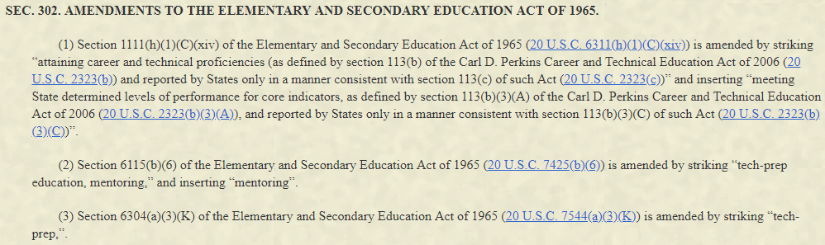

These three amendments are noted in footnotes added to the compilation provided by OLC.

The new July 31, 2018 edition [highlighting is from my ‘compare versions’ run through Adobe Acrobat Pro XI]:



The now-replaced March 23, 2018 edition:



OLC included Currency/Note blurbs (reiterating info posted elsewhere on their website) on page 1 of the document, altering the March 23, 2018 page/text margins for pages 1-117. Margins revert to identical to the March 23, 2018 version from pages 118-306, going off kilter again for pages 307-313 due to an added footnote. The final out-of-sync portion is pages 339-350. For those of you who print out ESEA and “tab it up” in a binder, this might be useful information. If I used that method (some of my office colleagues do), I might just reprint the first page to show the proper P.L. and date and make a note about the July 1, 2019 changes.

The only actual changes to the OLC compilation are three footnotes, indicating the future changes. These footnotes appear on pages 46, 307 and 339 of the new .pdf edition, corresponding with the three amendments of Section 302 of P.L. 115-224 shown above.

Best,

Bryan P. Lieb, Esq. | State Ombudsman

Office of Federal Programs

MISSISSIPPI DEPARTMENT OF EDUCATION

P.O. Box 771 | Jackson, MS | 39205-0771

Tel (601) 359-3499 | Desk (601) 359-2981

Fax (601) 359-2587 | [BLieb@mdek12.org](mailto:BLieb@mdek12.org)

