New Jersey Department of Education
Collaborative Monitoring Risk Assessment Tool

Purpose
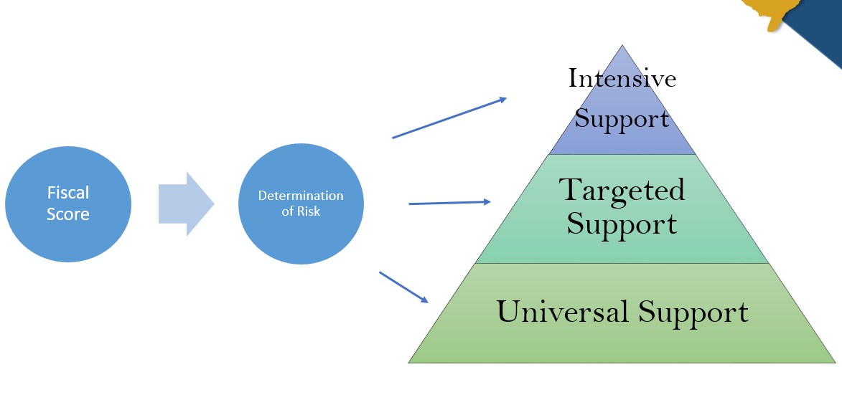
The Collaborative Monitoring Risk Assessment Tool is designed to meet the requirements set forth in 2 CFR § 200.331 for pass-through entities of federal grant awards. Specifically, the tool will be used to evaluate each Local Educational Agency’s (LEA’s) risk of noncompliance with Federal statutes and regulations, and the level of support the LEA will receive through monitoring activities conducted by the New Jersey Department of Education (NJDOE). The current process is reflected below:

For the 2020-2021monitoring cycle, each LEA will receive a fiscal score, which will determine the level of risk and the subsequent NJDOE response. Support to be provided is as follows: Intensive Support – on-site collaborative monitoring; Targeted Support – desk monitoring; Universal Support – standard support offered to all districts.

Over the 2020–2021 monitoring cycle, each program office will develop a program risk assessment tool, which will be combined with the fiscal score to provide one risk score.
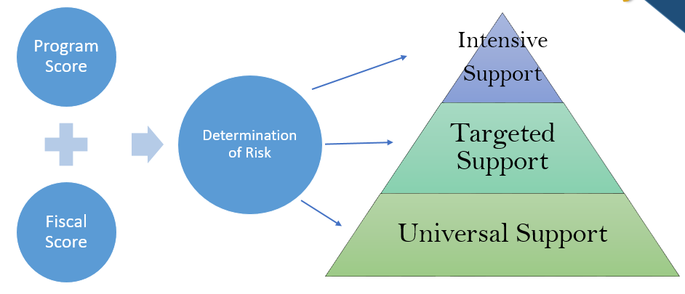
The graphic below illustrates the proposed process:

New Jersey Department of Education
Collaborative Monitoring Risk Assessment Tool
Risk Indicators
Indicator Variables
- Proficiency Rate for Federal Accountability for ELA

Data Source: Performance Reports
 | Category | Points
The LEA met the target or the goal for the proficiency rate | 0 | 0 points
The LEA met the target or the goal within one standard deviation | 1 | 2.5 points
The LEA did not meet the target or the goal for the proficiency rate | 2 | 5 points
- Proficiency Rate for Federal Accountability for Math

Data Source: Performance Reports
 | Category | Points
The LEA met the target or the goal for the proficiency rate | 0 | 0 points
The LEA met the target or the goal within one standard deviation | 1 | 2.5 points
The LEA did not meet the target or the goal for the proficiency rate | 2 | 5 points
- Graduation Rate (4 and 5 Year)

Data Source: Performance Reports
 | Category | Points
The LEA met the 4 year and the 5 year graduation rate targets (or met the target for one and the other is not applicable) | 0 | 0 points
The LEA did not meet the target for either the 4 year or the 5 year graduation rate | 1 | 2.5 points
The LEA did not meet the target for both the 4 year and the 5 year graduation rate | 2 | 5 points
- Accurate data submissions for NJSmart (Summary of nine annual NJ Smart submissions)

Data Source: QSAC report from IT
 | Category | Points
The LEA’s NJSmart data submissions did not contain any errors | 0 | 0 points
The LEA’s NJSmart data submissions contained errors, but none at 1.5% or more | 1 | 3.3 points
The LEA’s NJSmart data had one submission with an error rate of 1.5% or more | 2 | 6.7 points
The LEA’s NJSmart data had two or more submissions with an error rate of 1.5% or more | 3 | 10 points

- Percentage of funds drawn down by June 30th during current fiscal year (across following programs – Title 1, Part A, Title II, Part A, Basic, Preschool, Perkins and ESSER)

Data Source: EWEG
 | Category | Points
The LEA has been paid 75% or more of budgeted funds by June 30th | 0 | 0 points
The LEA has been paid between 60%-74% of budgeted funds by June 30th | 1 | 2.5 points
The LEA has been paid between 45%-59% of budgeted funds by June 30th | 2 | 5 points
The LEA has been paid between 25%-44% of budgeted funds by June 30th | 3 | 7.5 points
The LEA has been paid under 25% of budgeted funds by June 30th | 4 | 10 points
- Frequency of reimbursement requests (calculated as an average across all programs including ESSER)

Data Source: EWEG
 | Category | Points
The LEA submitted, on average across all programs, a reimbursement request in every quarter | 0 | 0 points
The LEA submitted, on average across all programs, a reimbursement request in all but one quarter | 1 | 2.5 points
The LEA submitted, on average across all programs, a reimbursement request in two quarters, only | 2 | 5 points
The LEA submitted, on average across all programs, a reimbursement request in one quarter, only | 3 | 7.5 points
The LEA did not submit, on average across all programs, a reimbursement request in any quarter | 4 | 10 points
- Number of Application Revision Rounds (across all programs including ESSER)
Data Source: EWEG
 | Category | Points
The LEA had below the average number of revision rounds for all programs it participated in. | 0 | 0 points
The LEA was at the average number of revision rounds for at least one program and at or below the average on any other program. | 1 | 3.3 points
The LEA was one revision above the average on at least one program | 2 | 6.7 points
The LEA was two revisions or more above the average on at least one program | 3 | 10 points
- Late grant application (across all programs)
Data Source: EWEG
 | Category | Points
The LEA submitted all grant application(s) by the due date for all programs | 0 | 0 points
The LEA submitted one program grant application after the due date | 1 | 5 points
The LEA submitted two or more program grant applications after the due date | 2 | 10 points

- Late final report submission (across all programs)
Data Source: EWEG
 | Category | Points
The LEA submitted all program final reports by the due date | 0 | 0 points
The LEA submitted one program final report after the due date | 1 | 5 points
The LEA submitted two or more program final reports after the due date | 2 | 10 points
- Late revision submission (ESEA Only)
Data Source: EWEG
 | Category | Points
The LEA needed no revisions or NJDOE received revisions within 45 days after the deadline | 0 | 0 points
The LEA submitted a revision 45 days after the deadline | 1 | 10 points
- Total amount of Federal awards

Data Source: OGM
 | Category | Points
LEA total Federal award amount is < $100,000 | 0 | 0 points
LEA total Federal award amount is $100,000 to $249,999 | 1 | 1.7 points
LEA total Federal award amount is $250,000 to $499,999 | 2 | 3.3 points
LEA total Federal award amount is $500,000 to $999,999 | 3 | 5 points
LEA total Federal award amount is $1,000,000 to $2,999,999 | 4 | 6.7 points
LEA total Federal award amount is $3,000,000 to $4,999,999 | 5 | 8.3 points
LEA total Federal award amount > $5,000,000 | 6 | 10 points
District Monitoring Scale Score Construction
A district’s score on 11 indicators will be summed. Districts may not have a score on all 11 indicators. (For example, not all districts have a high school so they may not have a score on Indicator 3 – Graduation Rate.) Districts will need to have scores on 8 or more indicators to be included. To adjust for variation in the number of scales a district has a score on, the sum of all indicators is divided by the maximum number of points a district may have. This creates the district’s final Monitoring Scale Score, which can be interpreted as a percentage of possible points from 0 to 100.
- If a district scores a maximum of 10 points on all 8 fiscal indicators and a maximum of 5 points on all 3 academic indicators, the sum of all indicators is 95 and the Monitoring Scale Score would be 95 points/95 possible scale points, which would equal 100%. Likewise, if a district scores 10 points on 7 fiscal indicators and 5 points on 1 academic indicator and does not have a score on 3 indicators, it would have 75 points/75 possible scale points for an equivalent score of 100%.
- If a district has a sum of 70 points on all 11 scales, the scale score is 70/95, or 73.7%.
- Districts will be rank ordered by their scale percentage score, from highest to lowest. A high score indicates the worst performance on all indicators; a low score indicates the best performance on all indicators.

Determination of Intensive Support and Targeted Support Districts
After the districts are rank ordered by their Monitoring Scale Score, the following criteria determine the district’s placement in the support tiers:
- Intensive Support – the districts with the top 20 scores
- Targeted Support – the districts with scores ranking from 21-120
- Universal Support – all other districts
- As a last step, NJDOE will move districts in these tiers based on their past collaborative monitoring history and current QSAC monitoring as described in the Adjustment Variables section below.

Adjustment Variables
- Years since last monitored
LEAs will be ranked and then organized into tiers based upon their final Monitoring Scale Score.
- Step 1: LEAs identified for the Intensive tier who received intensive support within the last two years will be moved down to the Targeted tier.
- Step 2: When districts in the Intensive tier are bumped down, they will be replaced by the highest scoring district(s) in the Targeted tier, assuming those districts have not been monitored in the past two years.
- Step 3: LEAs identified for the Targeted tier who were monitored within the last two years will be moved to the Universal Support tier.
- Step 4: When districts in the Targeted tier are bumped down, they will be replaced by the highest scoring district(s) in the Universal Support tier, assuming those districts have not been monitored in the past two years.
13. QSAC monitoring in current year
QSAC is the NJDOE’s self-evaluation system for LEAs. This field will indicate whether the LEA currently is involved in the QSAC process. If an LEA is in the monitoring cycle for QSAC, they will be excluded from Intensive Collaborative Monitoring, but not Targeted Support.
- Step 1: LEAs identified for the Intensive tier that are under QSAC monitoring in the current year will be moved down to the Targeted tier.
- Step 2: When districts in the Intensive tier are bumped down, they will be replaced by the highest scoring district(s) in the Targeted tier, assuming those districts are not under QSAC monitoring in the current year.
- Step 3: LEAs identified for the Targeted tier that are under QSAC monitoring in the current year will remain in Targeted Support tier.

Indicators 1 to 3 are related to academic performance and are standardized on a scale from 0 to 5. Each of these indicators are weighted to account for 5.263% of the Scale’s value. Indicators 4 to 11 are related to fiscal performance and are standardized on a scale from 0 to 10. Each of these indicators are weighted for 10.526% of the Scale’s value.
In 2019, the average number of revision rounds was 4 for ESEA, 2 for IDEA and 5 for Perkins.

