GUIDANCE

STATE EDUCATIONAL AGENCY PROCEDURES FOR ADJUSTING BASIC, CONCENTRATION, TARGETED, AND EDUCATION FINANCE INCENTIVE GRANT ALLOCATIONS DETERMINED BY THE
U.S. DEPARTMENT OF EDUCATION



U.S. Department of Education
Office of Elementary and Secondary Education

May 23, 2003

Other than statutory and regulatory requirements included in the document, the contents of this guidance do not have the force and effect of law and are not meant to bind the public in any way. This document is intended only to provide clarity to the public regarding existing requirements under the law or agency policies.

STATE EDUCATIONAL AGENCY PROCEDURES FOR

ADJUSTING BASIC, CONCENTRATION, TARGETED, AND EDUCATION FINANCE INCENTIVE GRANT ALLOCATIONS DETERMINED BY THE DEPARTMENT OF EDUCATION

INTRODUCTION

Title I, Part A of the Elementary and Secondary Education Act (ESEA), as amended by the No Child Left Behind Act of 2001, continues the requirement that the Department of Education (ED) calculate Basic, Concentration, Targeted, and Education Finance Incentive Grant allocations to local educational agencies (LEAs). In calculating Title I allocations, we use a list of LEAs provided by the Census Bureau, which is based on census maps that are generally two years old. We determine the eligibility of each LEA for Basic, Concentration, Targeted, and Education Finance Incentive Grants and calculate allocations using the number of “formula children” ages 5 through 17 years counted under section 1124(c) of Title I. The data used for allocation purposes include Census Bureau estimates of the number of children living in poverty. We also use annually collected counts of children ages 5 through 17 years in families above poverty receiving Temporary Assistance for Needy Families (TANF) and in foster homes as reported by the Department of Health and Human Services, and children living in institutions for neglected children as reported by each State to ED. In addition, ED has created an LEA record for each State that contains counts of all the children living in local institutions for delinquent children or adult correctional facilities. The State educational agency (SEA) distributes funds that ED allocates to this "LEA" to eligible LEAs under Part D, Subpart 2 of Title I.

Because the Department’s list of LEAs does not match the current universe of LEAs for many States, SEAs must adjust ED’s Title I, Part A allocations to account for LEA boundary changes and for newly created eligible LEAs, such as charter schools, that are not included in the Department’s calculations. In addition, SEAs must adjust ED’s allocations in order to (1) reserve funds for school improvement activities, State administration, and the State academic achievement awards program, and (2) allow, in the case of several States, for the use of alternative data to redistribute ED-determined allocations among LEAs with fewer than 20,000 residents.

Sections 200.70 through 200.75 and §200.100 of the final regulations published on December 2, 2002 address the basic rules that an SEA must follow in adjusting ED-determined LEA allocations. This guidance elaborates on these rules by providing guidance and examples of how SEAs adjust ED-determined Basic, Concentration, Targeted, and Education Finance Incentive Grant allocations to account for the existence of eligible LEAs that were not included in our LEA calculations and to make final grants to LEAs. The guidance addresses the following issues:

- Determining numbers of Title I formula children and the eligibility of LEAs not on the Census Bureau’s list of LEAs that ED uses to determine LEA allocations. (Step 1)

- Establishing allocations for all eligible LEAs (including those not on the Census list) within the State. (Step 2)

- Reserving funds for school improvement activities, State administration, and the State academic achievement awards program and adjusting allocations to reflect “hold-harmless” requirements. (Steps 3 and 4)

This guidance further outlines several special procedures to follow with regard to—

- How States adjust formula counts and allocations when they do not have the information necessary to track children transferring from an LEA on the Census list to a special LEA not on the Census list;

- How States may use alternative data for “small” LEAs (those with fewer than 20,000 total residents) to determine eligibility and to redistribute ED-determined Basic, Concentration, Targeted, and Education Finance Incentive Grant allocations among its small LEAs; and

- How small States in which the number of formula children make up less than 0.25 percent of the national total may allocate Concentration Grants to LEAs.

The chart on the next page outlines the general steps an SEA follows when adjusting ED’s Basic, Concentration, Targeted, and Education Finance Incentive Grant allocations.

OUTLINE OF STEPS TO ADJUST ED's BASIC, CONCENTRATION, TARGETED, AND EDUCATION FINANCE INCENTIVE GRANT ALLOCATIONS

Special Procedures
- Adjust formula counts in LEAs on Census list used by ED to account for LEA consolidations and special LEAs not on Census list.
- Based on adjusted formula counts, determine whether all LEAs are eligible for Basic, Concentration, Targeted, and Education Finance Incentive Grants.

States that do not have the information to track children transferring from sending LEAs to special LEAs
SEA may determine the formula count and initial allocation for its special LEAs by--
- Equating Statewide alternative poverty data to the Census poverty data for the State.
- Applying the equating factor to each special LEA’s count of formula children based on the alternative poverty data to derive a revised poverty estimate and determine eligibility for Basic, Concentration, Targeted, and Education Finance Incentive Grants.
- Based on the percent that the revised number of formula children for special LEAs is of the total for the State, applying that percent to the State's total Title I allocation to determine how much to reserve and distribute to special LEAs eligible for Basic, Concentration, Targeted, and Education Finance Incentive Grants.
STEP 1
Adjust formula
counts

- Establish an initial Basic, Concentration, Targeted, and Education Finance Incentive Grant allocation for all eligible LEAs (including those not on the Census list) by adjusting ED-determined LEA allocations to account for formula children transferring to consolidated or special LEAs.
- Base adjusted initial LEA allocations for Basic, Concentration, Targeted, and Education Finance Incentive Grants on amount per formula child transferring from "sending" to "receiving" LEAs.

STEP 2
Adjust ED-
determined
allocations based
on adjusted
formula counts
States that use alternative data for small LEAs (under 20,000)
Small LEA procedures:
- Process is applied separately to Basic, Concentration, Targeted, and Education Finance Incentive Grants
- The amount available for redistribution is the sum of adjusted initial allocations determined for small LEAs after completing Step 2.
- Eligibility based on alternative data selected by SEA (and approved by ED).
- Distribution based on each eligible small LEA's share of alternative formula count for all eligible small LEAs.
- Hold-harmless applies to all eligible small LEAs (including small LEAs that received a Concentration Grant within the past four years.)
- If amount available for small LEAs is not enough to satisfy hold-harmless, an SEA ratably reduces all eligible small LEAs to the amount available.
Large LEA (20,000 and over) procedures:
- No change from the initial allocations determined in Step 2

STEP 3
Add initial
Add initial Basic, Concentration, Targeted and Education Finance Incentive Grant allocations for each LEA to determine its total Title I, Part A allocation.
adjusted allocations
for all Title I,
Part A formulas

Reserve funds in the following order:
- Reserve 2% of total Title I, Part A allocations (4% for fiscal year 2004 and after) for Title I school improvement activities. In reserving school improvement funds, an SEA must ensure that no LEA (including the amount allocated under Part D, subpart 2) is reduced to less than the total Title I, Part A amount it received in the prior year.
- Reserve funds for State administration and State academic achievement awards.
In reserving funds for State administration and the State academic achievement awards program, an SEA may—
- Proportionately reduce each LEA’s total Title I, Part A allocation even if its final allocation falls below its hold-harmless level; or
- Proportionately reduce each LEA’s total Title I, Part A allocation while ensuring that no LEA receives in total less than its appropriate hold-harmless amount.

STEP 4
Reserve funds for
school improvement,
State administration,
& State academic
achievement awards
program

SEA PROCEDURES FOR ADJUSTING BASIC, CONCENTRATION, TARGETED, AND EDUCATION FINANCE INCENTIVE GRANT ALLOCATIONS DETERMINED BY THE DEPARTMENT OF EDUCATION

STEP 1: Adjust formula counts

Under this step the SEA estimates the number of formula children and determines eligibility for each LEA not on the Census list that falls into one of the three categories outlined below.

- A new LEA created as a result of a consolidation: In the case of an LEA not on the Census list (from here on referred to as a “new LEA”) that results from the consolidation of two or more LEAs (from here on referred to as “sending LEAs”), each of which is on the Census list, and that are (1) serving similar grade spans; or (2) serving complementary grade spans (e.g., a unified LEA created from one or more elementary LEAs and one or more secondary LEAs):

- The number of formula children in the new LEA = the sum of the total number of formula children in the sending LEAs that make up the new LEA. [See Example 1: Column 5]

- The 5-17 population of the new LEA = the sum of the total 5-17 populations of the sending LEAs that make up the new LEA. [Example 1: Column 6]

- The SEA calculates the percentage of children who are formula children in the new LEA [Example 1: Column 5/Column 6]

The results determine whether each new LEA is eligible to receive a Basic, Concentration, Targeted, or Education Finance Incentive Grant.

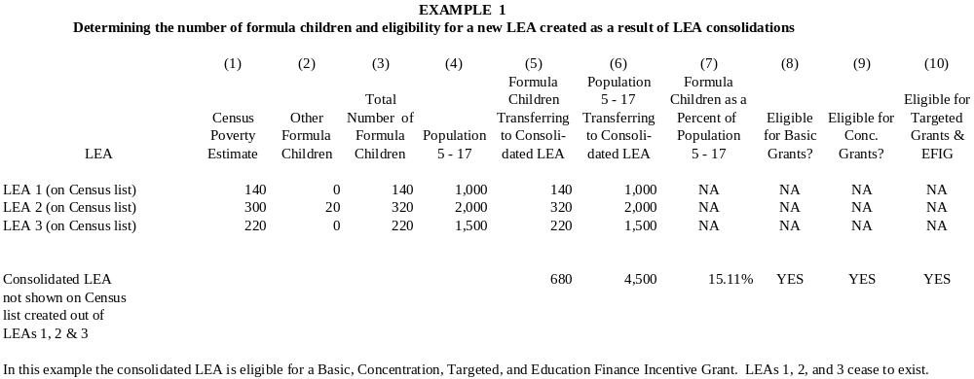

- A new LEA that is created from parts of LEAs on the Census list: For this situation, the SEA uses the following procedures to--

- Determine the number and percentage of formula children in the new LEA.

- The number of formula children in the new LEA = the sum of the formula children transferring to the new LEA from each sending LEA. [See Example 2: Column 4]

- The 5-17 population of the new LEA = the sum of the 5-17 population transferring to the new LEA from each sending LEA. [Example 2: Column 7]

- The SEA calculates the percentage of children who are formula children in the new LEA. [Example 2: Column 4/Column 7]

- Adjust the number and percentage of formula children in each sending LEA.

- The SEA reduces the number of formula children by the number transferring to the new LEA. [Example 2: Column 5]

- The SEA reduces the total of 5-17 year olds by the number transferring to the new LEA. [Example 2: Column 8]

- The SEA recalculates the percentage of children who are formula children in each sending LEA. [Example 2: Column 5/Column 8]

The results determine whether the new LEA is eligible and whether each affected sending LEA continues to be eligible to receive a Basic, Concentration, Targeted, or Education Finance Incentive Grant. In Example 2, all of LEAs 1 and 3 and part of LEA 2 consolidate to form a new LEA.

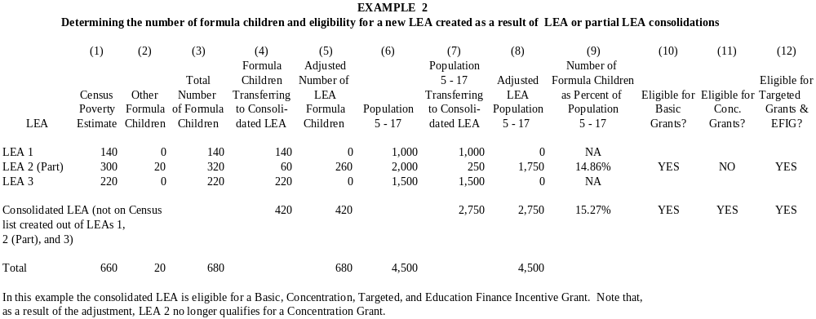

- Charter schools and other types of special LEAs: For each LEA not on the Census list (for instance, a charter school that has the legal status of an LEA, a regional vocational/technical school LEA, or another type of special LEA, from here on referred to as a “special LEA”), the SEA obtains a count of the formula children and children 5-17 for the special LEA and subtracts these counts from each sending LEA.

NOTE: Because Census poverty data are not available for special LEAs, the SEA must derive an estimate of Census poverty children for each special LEA and determine from which LEAs these children came. To do that, the SEA may use an alternative poverty data source, so long as these alternative data are available for both the sending and special LEAs.

- For each special LEA:

- The special LEA reports to the SEA its total 5-17 enrollment and identifies the LEAs from which those children came.

- The special LEA reports to the SEA a count of low-income children, using alternative poverty data that are from the same time period as the count of the special LEA’s 5-17 population.

- The SEA uses the total 5-17 population and the number of low-income children in the special LEA to derive an estimate of Census poverty children in each special LEA.

- The SEA adds any other formula children reported as enrolled in the special LEA to determine the total number of formula children in the special LEA.

- The SEA calculates the percentage of children who are formula children in the special LEA.

- For each sending LEA:

- The SEA reduces the total 5-17 population by the number transferring to the special LEA.

- The SEA reduces the number of Census poverty children in each sending LEA by the estimate of Census poverty children who transferred from that LEA to a special LEA (determined in (a) above).

- The SEA adds its count of any other formula children who continue to reside in the sending LEA to determine a revised total of formula children in the sending LEA.

- The SEA recalculates the percentage of children who are formula children in the sending LEA.

The results determine Basic, Concentration, Targeted, and Education Finance Incentive Grants eligibility for each special LEA and each affected sending LEA.
The following examples illustrate how an SEA makes this determination for special LEAs and for affected sending LEAs.

- Examples 3 & 4: determining the number of formula children and eligibility for special LEAs that draw their children solely from a single sending LEA.

- Examples 5 & 6: determining the number of formula children and eligibility for special LEAs that draw children from several sending LEAs.

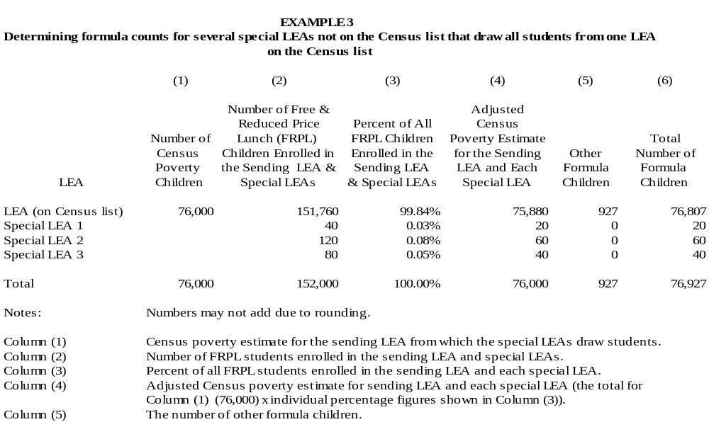

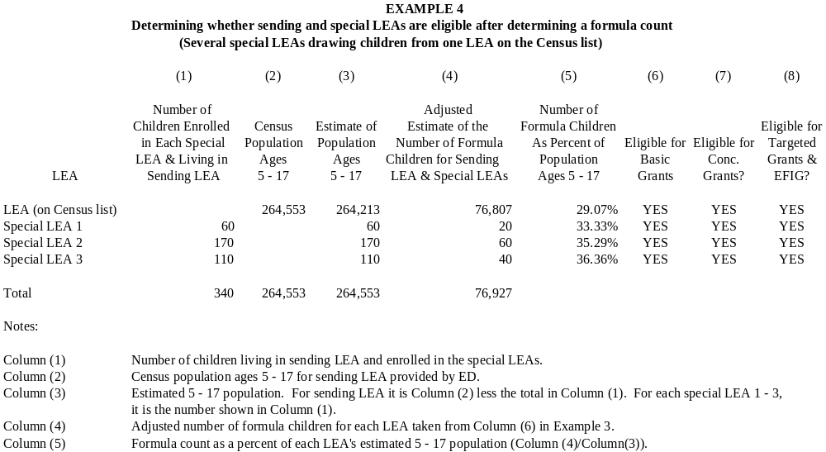

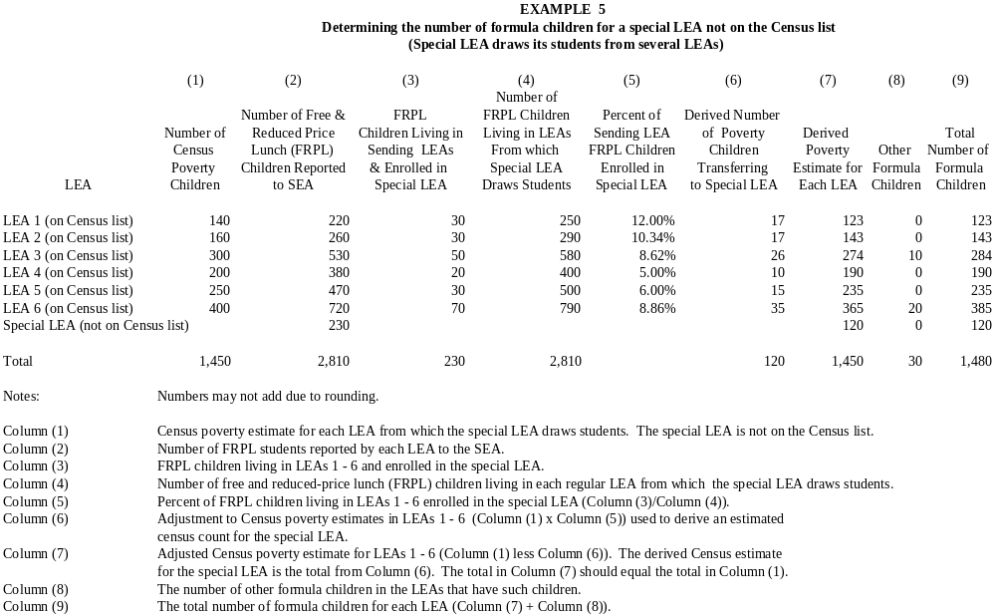

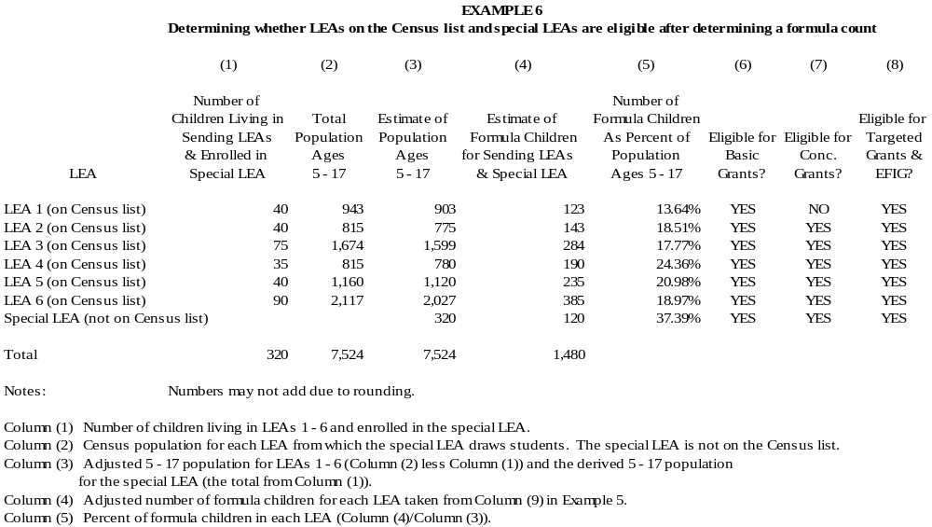

STEP 2: Adjust initial allocations based on adjusted formula counts

In this step the SEA adjusts ED-determined Basic, Concentration, Targeted, and Education Finance Incentive Grant allocations for every eligible LEA in the State based on the adjusted formula counts determined in Step 1.

- For each LEA receiving an ED allocation that is unaffected by boundary changes or the creation of special LEAs, the initial allocation continues to be the ED allocation at this stage in the process. The SEA makes no adjustments at this time.

- For each LEA that sends children to an LEA not on the Census list, the SEA adjusts the ED- determined allocation as follows:

- The SEA determines an initial amount per formula child for each sending LEA on the Census list contributing formula children to an LEA not on the Census list by dividing the total allocation from ED by the total number of formula children in the sending LEA (using ED data).

- The SEA reduces the ED allocation for each sending LEA on the Census list by an amount equal to the number of formula children transferring from such an LEA multiplied by the LEA’s allocation per formula child determined above.

- Any amounts for Basic, Targeted, and Education Finance Incentive Grants remaining in sending LEAs no longer eligible for these grants revert to the SEA and are part of the funds available to reserve for school improvement, State administration, and the State academic achievement awards program in Step 4.

- Any amounts for a Concentration Grant remaining in a sending LEA that is no longer eligible for a Concentration Grant but that received a Concentration Grant within the past four years remain with that LEA.

- For each LEA not on the Census list, the SEA determines the amount transferring from the sending LEAs as follows:

- The amount transferring to each LEA not on the Census list equals the sum of the allocations subtracted from each sending LEA contributing formula children to the receiving LEA. That is, the amount an LEA not on the Census list receives is the sum of the amounts that have followed the formula children from LEAs that are on the Census list.

- Any amounts for Basic, Targeted, and Education Finance Incentive Grants transferring to LEAs that are ineligible to receive funding for those programs revert to the SEA and are part of the funds available to reserve for school improvement, State administration, and the State academic achievement awards program (as described in Step 4).

- Any amounts, for a Concentration Grant transferring to an LEA not on the Census that is ineligible to receive a Concentration Grant but that received one within the last four years, revert to the SEA and are part of the funds available to reserve for school improvement, State administration, and the State academic awards program. (See the discussion of the hold-harmless provision on page 27 for an interpretation of what the term “last four years” means.)

Examples 7-9 illustrate how the SEA adjusts initial ED allocations to account for consolidations and the creation of special LEAs. Once the SEA completes this process, it will have a list of all LEAs eligible for Basic, Concentration, Targeted, and Education Finance Incentive Grants and an initial allocation for each LEA.

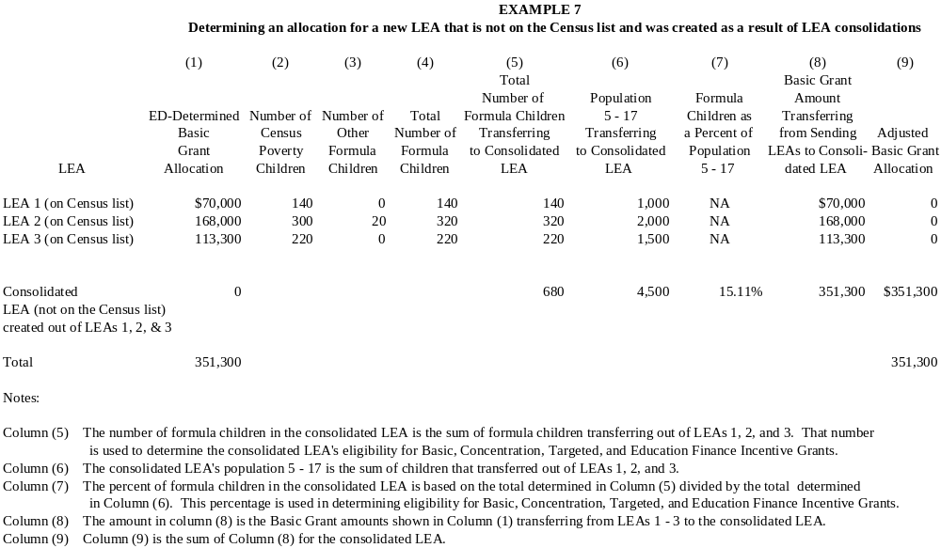

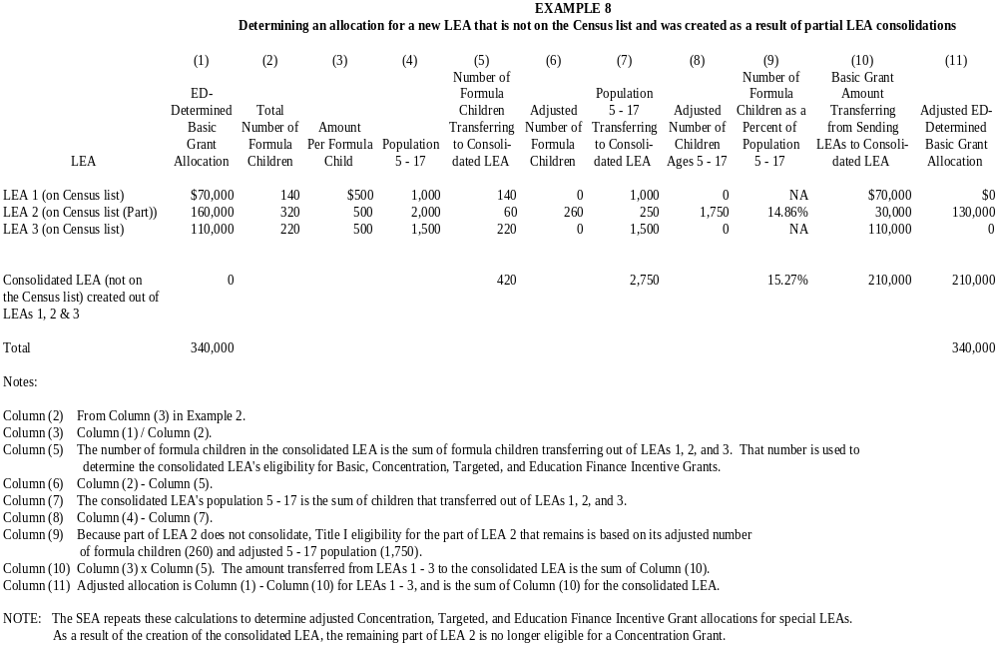

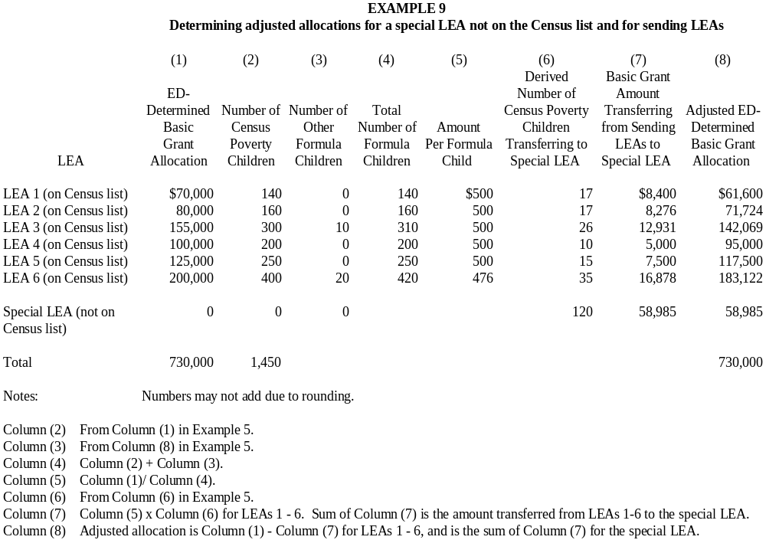

SPECIAL PROCEDURES

- States that do not have the information to track children transferring from sending LEAs to special LEAs

If an SEA does not have the necessary information to track children transferring from sending LEAs to special LEAs, the SEA may use a different method (discussed below) to determine Basic, Concentration, Targeted, and Education Finance Incentive Grant allocations.

- Example 10 illustrates how the SEA determines the number of formula children and eligibility for each special LEA.

- The SEA identifies an alternative poverty factor (e.g., Free and Reduced Price Lunch) available in total for the State and for each special LEA.

- The SEA develops an equating factor for the State that represents the following proportion:

Total number of Census poverty children in the State
Total number of poverty children in the State using the alternative poverty factor

- The SEA multiplies the equating factor by the number of poverty children (calculated using the alternative poverty factor) reported by the special LEA to obtain an estimate of the number of Census poverty children in the special LEA.

- The SEA determines the total number of formula children in each special LEA by adding together the estimated number of Census poverty children and all other formula children enrolled in the special LEA.

- The SEA uses the total number of formula children and the reported enrollment ages 5 through 17 in each special LEA to calculate the percentage of formula children in the special LEA. NOTE: in this method, the number and percentage of Census formula children in the other LEAs in the State are unchanged because the State has no data on the number of children transferring to the special LEA.

- The SEA determines Basic, Concentration, Targeted, and Education Finance Incentive Grant eligibility for each special LEA.

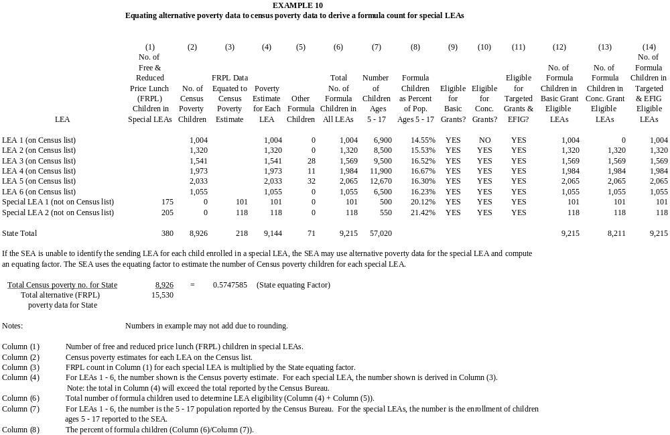

- Example 11 illustrates how the SEA, using this special procedure, determines Basic Grant allocations for special LEAs.

- The SEA divides the number of formula children in all eligible special LEAs by the total number of formula children for the State to determine the percentage of the State’s total formula children enrolled in all special LEAs.

___Total formula children in all eligible special LEAs__
Total formula children in all eligible LEAs in the State

- The SEA reduces the allocations to all LEAs on the Census list by the percentage just determined. The total amount taken from the eligible LEAs on the Census list becomes the amount reserved to make initial Basic Grant allocations to the special LEAs.

- The SEA determines the allocation for each eligible special LEA by multiplying the total amount reserved by the proportion of formula children enrolled by each special LEA.

In Example 11, the SEA first divides the formula count in Special LEA 1 by the total count for all eligible special LEAs to determine Special LEA 1’s share of formula children. The SEA then multiplies that share by the total amount reserved to determine Special LEA 1’s Basic Grant allocation. The SEA repeats this process for Special LEA 2.
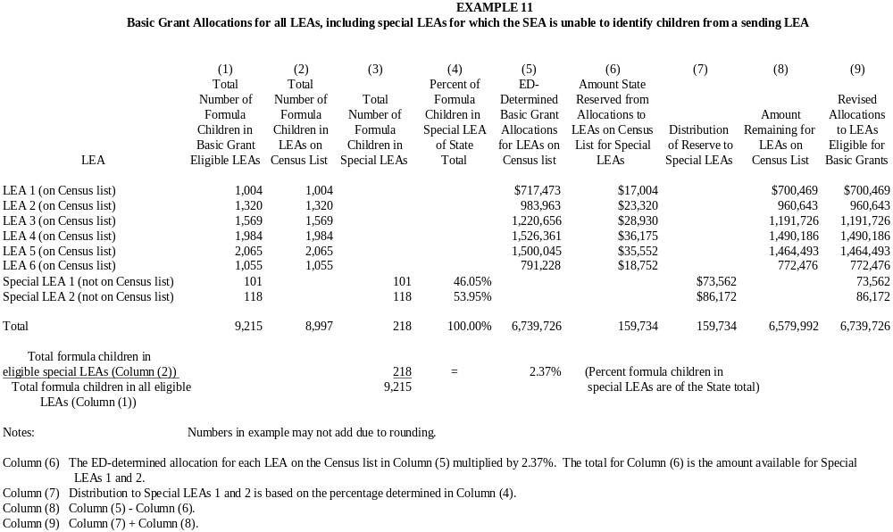

- Example 12 illustrates how the SEA, using this special procedure, determines Concentration Grant allocations for special LEAs.

- The SEA creates a list of all LEAs eligible to receive a Concentration Grant (including LEAs that fail to meet the eligibility thresholds but received a Concentration Grant allocation within the last four years. (See the discussion of the hold-harmless provision on page 27 for an interpretation of what the term “last four years” means.) The list includes LEAs on the Census list, new LEAs, and special LEAs.

- The SEA divides the number of formula children in all special LEAs on the list just created by the total number of formula children in all LEAs on that list to determine the percentage of the State’s total formula children enrolled in all special LEAs.

Total formula children in all special LEAs on the list
Total formula children in all LEAs on the list

- The SEA reduces the allocation to all LEAs on the Census list by the percentage just determined. The total amount taken from the LEAs on the Census list becomes the amount reserved to make initial Concentration Grant allocations to the special LEAs.

The SEA determines the Concentration Grant allocation for each special LEA by multiplying the total amount reserved by that LEA’s proportion of the formula children enrolled in all special LEAs in the State.

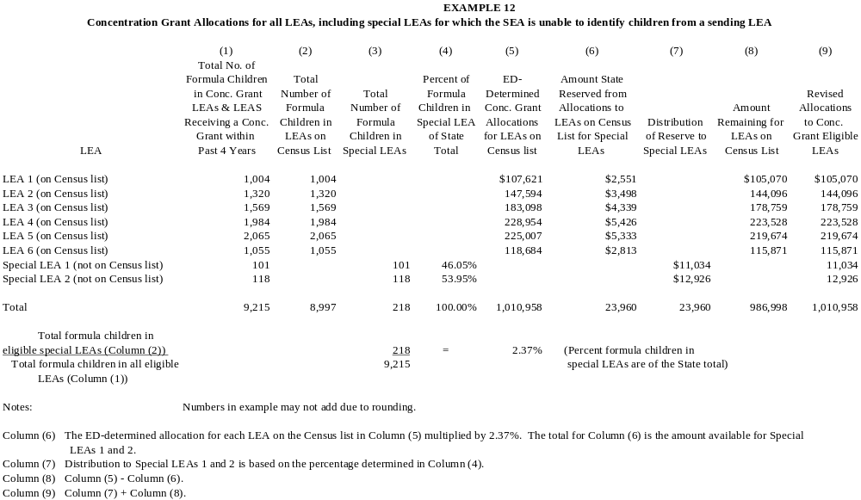
- States using an alternative method approved by ED under §200.74 to redistribute allocations to LEAs serving fewer than 20,000 total residents

Sections 1124(a)(2) (B), 1124A(a)(4)(c), and 1125(d) of Title I permit an SEA to combine the allocations that ED determined under each of the formulas for LEAs with fewer than 20,000 total residents ("small" LEAs) and use an alternative method approved by ED to redetermine each small LEA’s eligibility and redistribute funds among those LEAs based on those alternative data. Section 200.74 of the regulations applies this alternative data provision to Education Finance Incentive Grants. This provision does not affect the allocations for "large" LEAs (those with a total population of 20,000 or more). The allocations for these large LEAs would be the allocations that ED has determined, subject to adjustments needed to account for boundary changes and the creation of new LEAs and funds an SEA reserves for school improvement, State administration, and the State academic achievement awards program discussed in Steps 3 and 4.

The SEA identifies LEAs in the State serving a total population of fewer than 20,000 residents (hereinafter referred to as “small” LEAs) and the total allocation available for distribution to those small LEAs using alternative data approved by ED.

- LEAs serving fewer than 20,000 residents are those meeting one of the following criteria:

- Every LEA on the Census list identified by ED as serving fewer than 20,000 residents. (Note that for purposes of this provision, ED considers the LEA record in its allocation tables containing the Part D, subpart 2 allocation to be a large LEA not subject to adjustment as a small LEA.)

- Special LEAs receiving a Basic, Concentration, Targeted, or Education Finance Incentive Grant based on the procedures outlined in Steps 1 and 2 of this guidance.

- Any LEA resulting from a consolidation and not on the Census list that the SEA determines serves fewer than 20,000 residents.

- The SEA determines the amount of Basic, Concentration, Targeted, and Education Finance Incentive Grants available for allocation to small LEAs by summing the ED- determined allocations for each LEA serving fewer than 20,000 residents.

- Using the alternative poverty data approved by ED, the SEA determines the number of formula children ages 5 through 17 (including neglected children) for each small LEA. The SEA also establishes the total number of children ages 5 through 17 children for each small LEA. These alternative poverty data form the basis for determining an LEA’s eligibility for Basic, Concentration, Targeted, and Education Finance Incentive Grants and are used to redistribute initial allocations for all eligible small LEAs using the funds determined in 2B. NOTE: Poverty data and population data used to determine formula children percentages must be consistent with respect to the time period they cover.

Basic Grants

- Eligibility: The SEA determines that a small LEA is eligible for a Basic Grant, if (using the approved alternative poverty data source) it has at least 10 formula children and the number of those children is greater than 2 percent of its total 5-17 population.

- Allocation: The SEA redistributes the total Basic Grant funds available to eligible small LEAs as follows:

- The SEA determines the total number of formula children in all eligible small LEAs based on the alternative data used.

- The SEA divides the amount available for small LEAs determined in Step 2B by the total number of formula children in all small LEAs to determine a Basic Grant amount per formula child.

- The SEA multiplies the amount per formula child by the number of formula children in each eligible small LEA to determine the LEA’s Basic Grant allocation.

- Hold-harmless calculation: The SEA ensures that each eligible small LEA in the State (whether on the Census list or not) receives a percentage of the amount allocated to it in the preceding year based on the criteria outlined in the following table:

LEA’s Number of Title I Formula Children as a Percentage of its Total Population Ages 5 through 17 | Percentage Guarantee of  Prior-Year Allocation ¹
30 percent or more | 95
15 percent or more but less than 30 percent | 90
Less than 15 percent | 85

¹ The hold-harmless amount for an LEA is its preceding year’s allocation multiplied by the appropriate percentage.

- If an eligible small LEA’s Basic Grant allocation determined under the previous step is less than its prior-year hold-harmless amount, the SEA proportionately reduces the Basic Grant allocations for small LEAs in the State that are above their hold-harmless amounts until no small LEA in the State falls below its hold-harmless allocation.

- If the total allocation available for redistribution to small LEAs is not sufficient to bring every eligible small LEA up to its hold-harmless amount, the SEA proportionately reduces every eligible small LEA to the amount available.

NOTE: None of these adjustments can affect allocations to LEAs serving 20,000 or more residents or the ED-determined allocation for Part D, subpart 2.

- Concentration Grants

- Eligibility: The SEA determines that a small LEA is eligible for a Concentration Grant if it--

- Is eligible for a Basic Grant; and

- Has more than 6,500 formula children (using the approved alternative poverty data source) or the number of those children exceeds 15 percent of the total 5-17 population.

(2) Allocation: The SEA redistributes the total Concentration Grant funds available to eligible small LEAs as follows:

- The SEA determines the total number of formula children in all eligible small LEAs based on the alternative data used.

- The SEA divides the amount available for small LEAs by the total number of formula children in all small LEAs to determine a Concentration Grant amount per formula child.

- The SEA multiplies the amount per formula child by the number of formula children in each small LEA to determine the LEA’s Concentration Grant allocation.

(3) Hold-harmless calculation: The SEA ensures that each small LEA (whether on the Census list or not) receives, as appropriate, 85, 90, or 95 percent of the Concentration Grant amount allocated to it in the preceding year. (See table on page 26.) Note that the statute requires that an LEA not meeting the eligibility thresholds for Concentration Grants receives its hold-harmless amount for four consecutive years. Thus, an LEA not receiving a Concentration Grant allocation in the process described in step 2 above because it did not have enough formula children to qualify could receive a percent of its prior year’s allocation depending on its formula child rate if the LEA met the Concentration Grant eligibility threshold at any time during the past four years. EXAMPLE: An LEA that was last eligible for a Concentration Grant in school year (SY) 1998-99 but was not eligible in SY 1999-2000, SY 2000-2001, SY 2001-2002, and SY 2002-2003 will still receive its hold-harmless amount in SY 2002-2003. If that LEA, however, fails to meet the Concentration Grant eligibility thresholds for the next year (SY 2003-2004), it will no longer be eligible for the hold-harmless guarantee.

- If a small LEA’s Concentration Grant allocation determined under the previous step is less than its hold-harmless amount, the SEA proportionately reduces the Concentration Grant allocations for small LEAs in the State that received more than their hold-harmless amount until no small LEA in the State falls below its hold-harmless allocation.

- If the total Concentration Grant allocation available for redistribution to small LEAs is not sufficient to bring every small LEA up to its hold-harmless amount, the SEA proportionately reduces the Concentration Grant for every small LEA to the amount available.

NOTE: None of these adjustments can affect allocations to LEAs serving 20,000 or more residents or the ED-determined allocation for Part D, subpart 2.

- Targeted and Education Finance Incentive Grants

- Eligibility: The SEA determines that a small LEA is eligible for a Targeted Grant and an Education Finance Incentive Grant, if (based on a formula count that incorporates the alternative poverty data approved by ED and used for Basic Grant purposes) it has at least 10 formula children and the number of those children is at least 5 percent of its total 5-17 population.

- Weighted formula counts: Using the alternative data approved by ED, the SEA applies the LEA weights provided in section 1125(c)(2) and 1125A(d)(1)(B) of the Title I statute as follows:

Targeted Grants

Formula Count  as % of 5-17 Population | Weight
0 – 15.58%  >15.58% up to 22.11%  >22.11% up to 30.16 %  >30.16% up to 38.24%  >38.24% | 1.0  1.75  2.5  3.25  4.0

No. of Formula Children
1 – 691  692 – 2,262  2,263 – 7,851  7,852 – 35,514  35,515 or more | 1.0  1.5  2.0  2.5  3.0
Education Finance Incentive Grants (EFIG)

States with an Equity Factor of Less Than 0.1

Formula Count  as % of 5-17 Population | Weight
0 – 15.58%  >15.58% up to 22.11%  >22.11% up to 30.16 %  >30.16% up to 38.24%  >38.24% | 1.0  1.75  2.5  3.25  4.0

No. of Formula Children
1 – 691  692 – 2,262  2,263 – 7,851  7,852 – 35,514  35,515 or more | 1.0  1.5  2.0  2.5  3.0

States with an Equity Factor Greater Than or Equal to 0 .1 and Less Than 0.2

Formula Count  as % of 5-17 Population | Weight
0 – 15.58%  >15.58% up to 22.11%  >22.11% up to 30.16 %  >30.16% up to 38.24%  >38.24% | 1.0  1.5  3.0  4.5  6.0

No. of Formula Children
1 – 691  692 – 2,262  2,263 – 7,851  7,852 – 35,514  35,515 or more | 1.0  1.5  2.25  3.375  4.5

States with an Equity Factor Greater Than 0.2

Formula Count  as % of 5-17 Population | Weight
0 – 15.58%  >15.58% up to 22.11%  >22.11% up to 30.16 %  >30.16% up to 38.24%  >38.24% | 1.0  2.0  4.0  6.0  8.0

No. of Formula Children
1 – 691  692 – 2,262  2,263 – 7,851  7,852 – 35,514  35,515 or more | 1.0  2.0  3.0  4.5  6.0

In applying the weights for Targeted Grants and EFIG, the SEA uses the percentage or number that generates the highest weighted count. The SEA also applies the weights in steps, so that only children above each threshold receive the higher weight.

- Allocation: The SEA redistributes the total available for Targeted Grants and EFIG separately to eligible small LEAs as follows:

- The SEA determines the total number of weighted formula children in all eligible small LEAs based on the alternative data used.

- The SEA divides the amount available for small LEAs by the total number of weighted formula children in all small LEAs to determine a Targeted Grant amount and an EFIG amount per weighted formula child.

- The SEA multiplies the amount per weighted formula child by the weighted number of formula children in each small LEA to determine a small LEA’s Targeted Grant and EFIG allocations.

- Hold-harmless calculation: The SEA ensures that each eligible small LEA (whether on the Census list or not) receives, as appropriate, 85, 90, or 95 percent of the Targeted and EFIG amount allocated to it in the preceding year. (See table on page 26.) The number of formula children used to determine the hold-harmless percentage is based on the formula count using the alternative data, without applying the Targeted and EFIG weights.

- If an eligible small LEA’s Targeted Grant or EFIG allocation determined under the previous step is less than its hold-harmless amount, then the SEA reduces the Targeted or EFIG allocations for small LEAs in the State that receive more than their hold-harmless amount until no small LEA in the State falls below its hold-harmless allocation.

- If the total allocation available for redistribution to small LEAs under Targeted Grants or EFIG is not sufficient to bring every eligible small LEA up to its hold-harmless amount, then the SEA proportionately reduces every eligible small LEA to the amount available.

Note that because SY 2002-03 is the first year that Targeted Grants and EFIG were funded, there are no prior-year amounts against which to determine a hold-harmless amount. Thus, the hold-harmless provision has no effect on SY 2002-03 allocations.

- Allocation of Concentration grant funds to LEAs in States where the number of children ED used in the formula to calculate Title I allocations makes up less than 0.25 percent of the national total formula count

For certain States (Alaska, Delaware, New Hampshire, Vermont, and Wyoming) in which the number of formula children counted under section 1124(c) of the Title I statute was less than 0.25 percent of the national total on January 8, 2002, the SEA may allocate Concentration Grant funds--

- In accordance with the procedures outlined in Steps 1 and 2; or

- To LEAs in which the number or percentage of formula children exceeds the statewide average number or percentage of those children, without regard to ED’s LEA allocations, as follows:

Identify Eligible LEAs

- Identify as eligible those LEAs in which either the number or percentage of formula children exceeds the average number or percentage of those children in the State.

Note: If a State is using an alternative method approved by ED to distribute Basic Grants to small LEAs with less than 20,000 total residents, the SEA must determine LEA Concentration Grant eligibility and allocations based on the approved alternative method.

Distribute the State Allocation Among Eligible LEAs

- Add the count of formula children for all eligible LEAs identified in Step A.

- Divide the Concentration Grant amount made available to the State by the total number of formula children in Step B to determine an amount per child.

- Multiply the amount per formula child by the number of formula children in each eligible LEA to determine its Concentration Grant allocation.

Calculate Hold-Harmless

- Ensure that each LEA (whether on the Census list or not) receives, as appropriate, 85, 90, or 95 percent of the Concentration Grant amount allocated to it in the preceding year. (See table on page 26.) Note that the statute provides that an LEA not meeting the eligibility thresholds for Concentration Grants is guaranteed its hold-harmless amount for four consecutive years. If an LEA's allocation under the previous step is less than its hold-harmless amount, proportionately reduce the Concentration Grant allocations of the LEAs in the State (including the Ed-determined allocation for the Part D, Subpart 2) above their hold-harmless amounts to bring up the allocations of LEAs that are, at this stage, below their hold-harmless amounts. Repeat this process as necessary until no LEA in the State falls below its hold-harmless amount.

If the State’s total allocation for Concentration Grants is not sufficient to bring each LEA eligible for the hold-harmless protection up to its hold-harmless amount, then the SEA proportionately reduces every LEA to the amount available.

STEP 3: Add adjusted allocations determined in Steps 1 and 2 for all of the Title I, Part A formulas

At this point in the process, the SEA adds the adjusted LEA allocations determined after completing Steps 1 and 2 for Basic, Concentration, Targeted, and Education Finance Incentive Grants. The SEA uses the sum of these adjusted allocations as the basis for reserving funds from each LEA for school improvement, State administration, and the State academic achievement awards program as outlined in Step 4.

STEP 4: Reserve funds for school improvement, State administration, and State academic achievement awards program

School improvement: Section 1003 of ESEA requires that, for fiscal years (FY) 2002 and 2003, each SEA reserve 2 percent of the amount received from ED under Title I, Part A for school improvement activities authorized in sections 1116 and 1117 of Title I. The percentage reserved increases to four percent for FY 2004 and beyond. When reserving funds for this purpose, an SEA must ensure that no LEA receives less in total under Title I, Part A than the amount allocated to it in the prior year. An SEA must suballocate not less than 95 percent of the funds reserved for school improvement to LEAs in accordance with criteria specified in section 1003(c) of ESEA.

State administration: Section 1004 authorizes an SEA to reserve for State administration up to one percent from funds allocated to the State under Title I, Part A (Grants to LEAs), Part C (Migrant Education), and Part D, Subpart 1 (State Agency Neglected or Delinquent Program). The one percent reservation is a maximum. An SEA may reserve less than one percent from each of Parts A, C, and D (Subpart 1). Moreover, an SEA does not need to reserve the same percentage from each part.

If the amount calculated as available to be reserved for State administration through this process totals less than $400,000, an SEA may reserve up to $400,000. In any State reserving $400,000 for State administration, the SEA is no longer required to reserve funds proportionately from each of Parts A, C, and D (Subpart 1) and may, for example, take the reserve entirely out of Title I, Part A funds. However, in reserving $400,000, an SEA cannot reserve more funds for State administration from Part C or Part D (Subpart 1) than it would have, had it reserved proportionate funds from Parts A, C, and D (Subpart 1). The following table illustrates how an SEA could reserve the $400,000 maximum set aside for State administration:

Reservation Based on $400,000 Maximum

Program | State Allocation | Reserve Taken Proportionately from Parts A, C, and D ALLOWABLE |  | Reserve Taken Only from Part A ALLOWABLE | Reserve Taken Disproportionately from Parts C and D  NOT ALLOWABLE
Part A, LEA Grants | 32,795,992 | 349,738 |  | 400,000 | 330,000
Part C, Migrant Program | 4,572,256 | 48,759 | * | 0 | 60,000
Part D, Subpart 1, State Agency N or D Program | 140,920 | 1,503 | * | 0 | 10,000
Total | 37,509,168 | 400,000 |  | 400,000 | 400,000

* The amount of funds reserved from Part C and Part D, Subpart 1 cannot exceed the amount shown.

Section 1004 of ESEA further provides that if the sum of the amount allocated to all States under Title I, Part A, Part C, and Part D, Subpart 1 exceeds $14,000,000,000, an SEA may not reserve more than one percent of the amount the State would receive if $14,000,000,000 had been allocated among States under those parts. ED will provide further guidance should this situation occur.

State academic achievement awards program: Under section 1117(c)(2)(A) of Title I, an SEA may reserve up to 5 percent of the Title I, Part A amount a State received in excess of its prior year amount for the State academic achievement awards program required under section 1117(b)(1).

In reserving funds for school improvement, State administration, and the State academic achievement awards program, the SEA follows the procedures outlined below in the order shown:

- School improvement

  - Based on the total amounts determined after completing Step 3 of this guidance, determine which LEAs received more Title I, Part A funds compared to their final allocations received in the prior year. Only those LEAs in which the Step 3 amounts are greater than the final allocation received in the prior year are subject to the 2 percent (4 percent after FY 2003) reserve.

  - Ratably reduce the Title I, Part A allocations of the LEAs identified in the step above while ensuring that none receives less than the amount allocated to it by the SEA in the prior year.

If the amount available after completing Step 3 is not enough for the SEA to take the full percentage reserve for school improvement and still ensure that no LEA receive less than the Title I, Part A amount allocated to it in the prior year, then the SEA must reduce the percentage it reserves for school improvement activities.

- State administration and State academic achievement awards program

  - After reserving funds for school improvement activities, reserve the appropriate amount for State administration and the State academic achievement awards program.

  - Ratably reduce the LEA allocations to account for funds reserved for State administration and State academic achievement awards program. After ratably reducing each LEA’s allocation the SEA has two options:

- End the process at this point. An LEA’s allocation after completing this step becomes the final allocation even if that results in an LEA receiving less than 85, 90, or 95 percent of the total Title I, Part A amount allocated to it in the prior year.

- If an LEA’s total Title I, Part A allocation is less than its hold-harmless amount, proportionately reduce the allocations of the LEAs in the State (including the allocation for Part D, Subpart 2) that are above their hold-harmless amounts to bring up the allocations of LEAs below their hold-harmless amounts. Repeat this process as necessary until no LEA in the State falls below its hold-harmless amount.

Note that, although an SEA must first ensure that no LEA receives less than its prior-year Title I, Part A amount when reserving funds for school improvement, the SEA may reduce that same LEA’s Title I, Part A allocation to an amount that is less than its prior year allocation when reserving funds for State administration and the State academic achievement awards programs.

For an Outlying Area, if the amount available to be reserved is less than $50,000, the statute authorizes it to reserve up to $50,000 for State administration activities.

